Student Hand-in Assignment

Part 1 Answer the following questions
- What are the steps in a scientific fire investigation?

- What are the stages of fire development?

- Fill in the blanks. To create flaming combustion of a solid fuel, heat must be applied to the fuel to generate flammable vapors through either ___________________ or __________________.

- What is meant by the term “fuel-controlled fire”?

- What stage of fire is reached in this photograph?

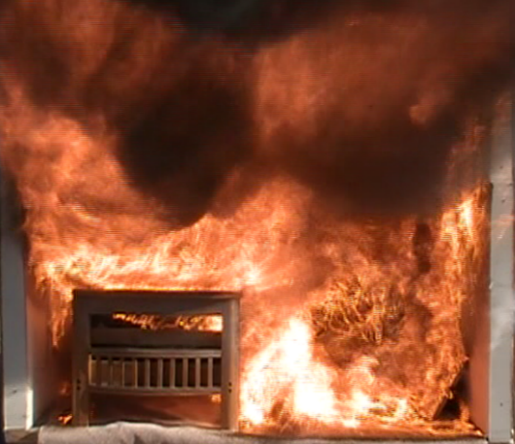

- Describe the fire development seen in the photograph below.
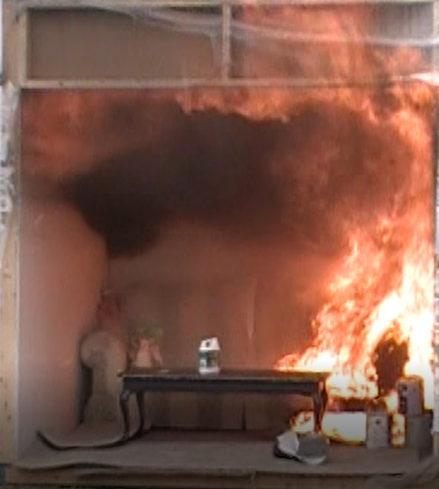

Julie can we substitute a video here for the photograph and ask the student to describe the stages of fire using the time stamp at the bottom of the video?

- Based only on this photograph, what is the direction of fire travel? Explain your answer by describing the fire and heat indicators visible in the photograph. You may insert graphics to highlight your response.

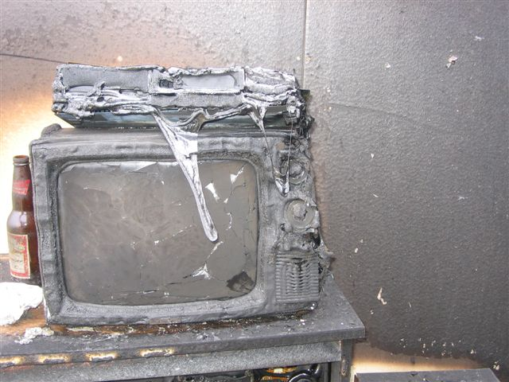

- What type of fire pattern is shown in this photograph and what would cause it? If you found it at a fire scene, what further action would you take?

- You are asked to investigate this fire scene and are told there is a body in the room seen in the lower left side of the photo below.
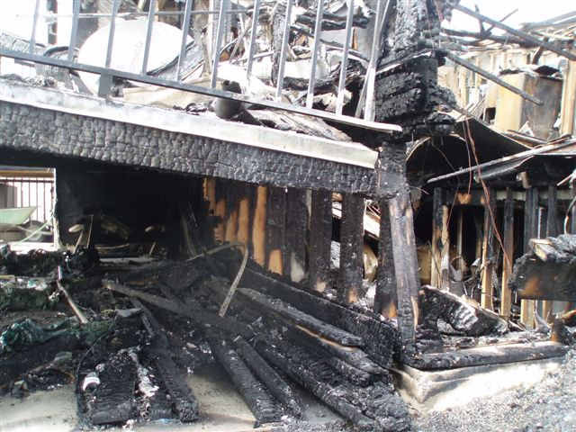

Answer the following questions.
Q. Who has statutory responsibility to investigate this fire and what is their role?
Q. In point form, note what actions would you take to investigate the fire.

- Based only on the photograph below, describe the visible fire patterns, what caused them, and where you think the fire started. What stage of fire was reached in this compartment?

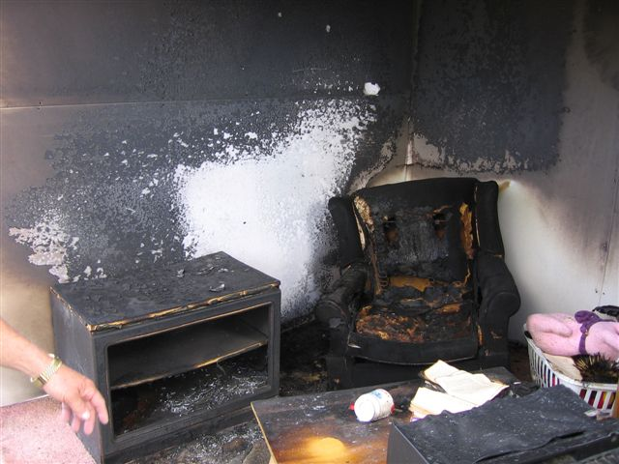

- An elderly man received serious burns resulting from the house fire seen in the photograph below. He is currently in intensive care at the burn unit and is unlikely to survive. You have been assigned to investigate the fire which may take several days. Describe the methods of security you would use to ensure continuity of the scene. Describe all instructions you would give to security personnel.

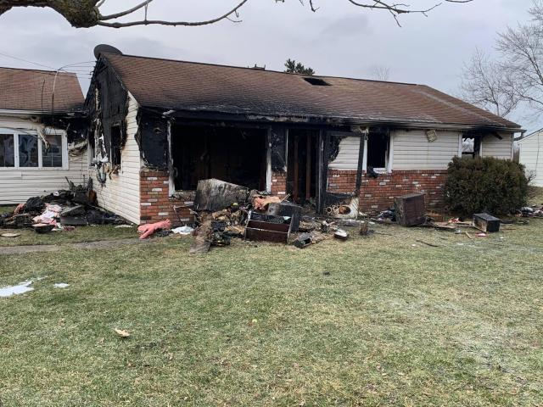

- While conducting a 360-degree external survey of the scene you find a plastic container containing an unidentified liquid. What action would you take?

- You are assigned to investigate a fire and explosion at the home in the 3 photographs below.
Photo #1
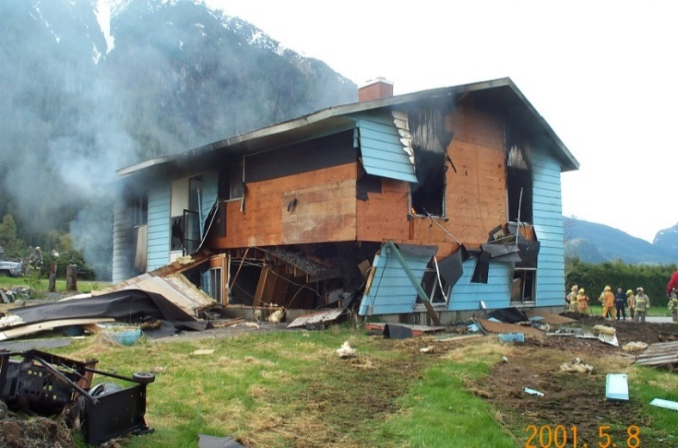
Photo #2
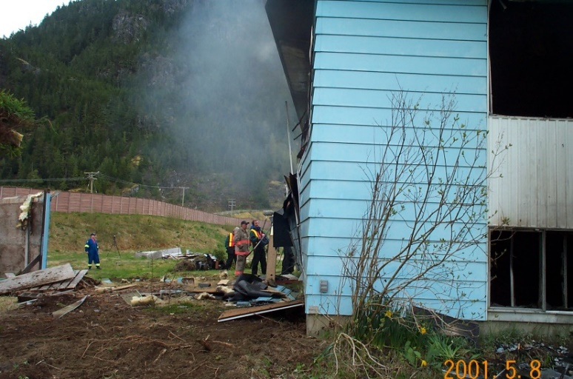
Photo #3
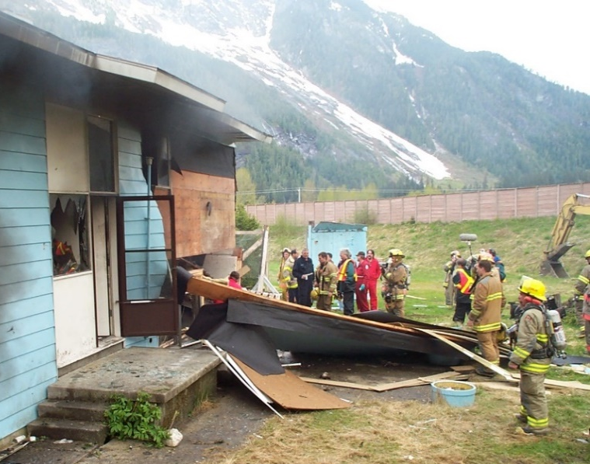
Based on these photographs describe:
- the type of explosion that took place.
- the explosive effects on the building
- where the blast originated
- possible causes of the explosion
- if this is high or low order damage

- During a fire scene examination, you identify a “V” shaped burn pattern on a wall like the one in this photograph. How will you preserve this as evidence?
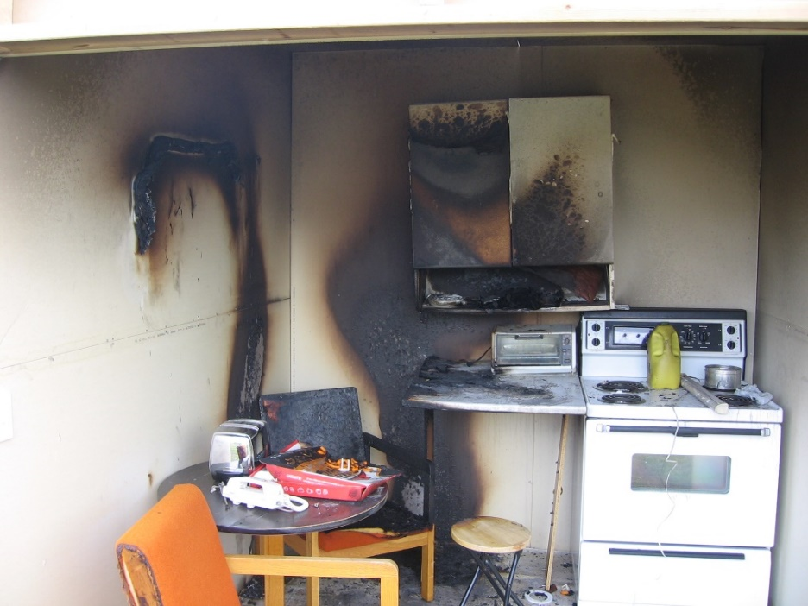

- During an investigation you find the remains of a plastic container in the area of origin of the fire. How would you process this evidence in line with the practices and legal requirements of your jurisdiction? If you are sending it to a lab for analysis fill out the Forensic Lab Submission form that can be found in the Materials Section of the Hand-in Assignment.
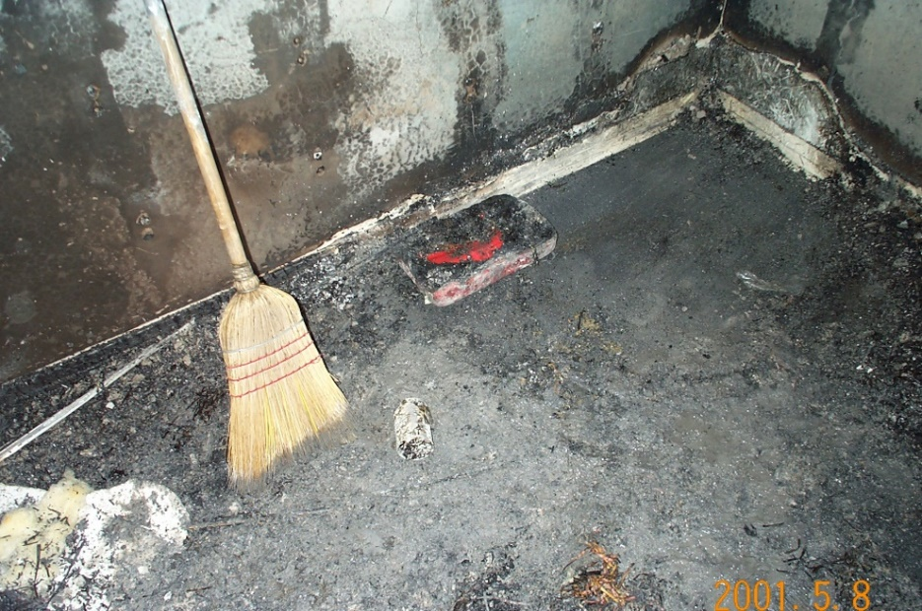

- As part of the initial fire investigation, you determine that the video monitor in the photograph below may have failed so you secured it as potential evidence. After your investigation is complete you determine that the damage to the monitor is the result of the fire not the cause of the fire. How would you dispose of it?

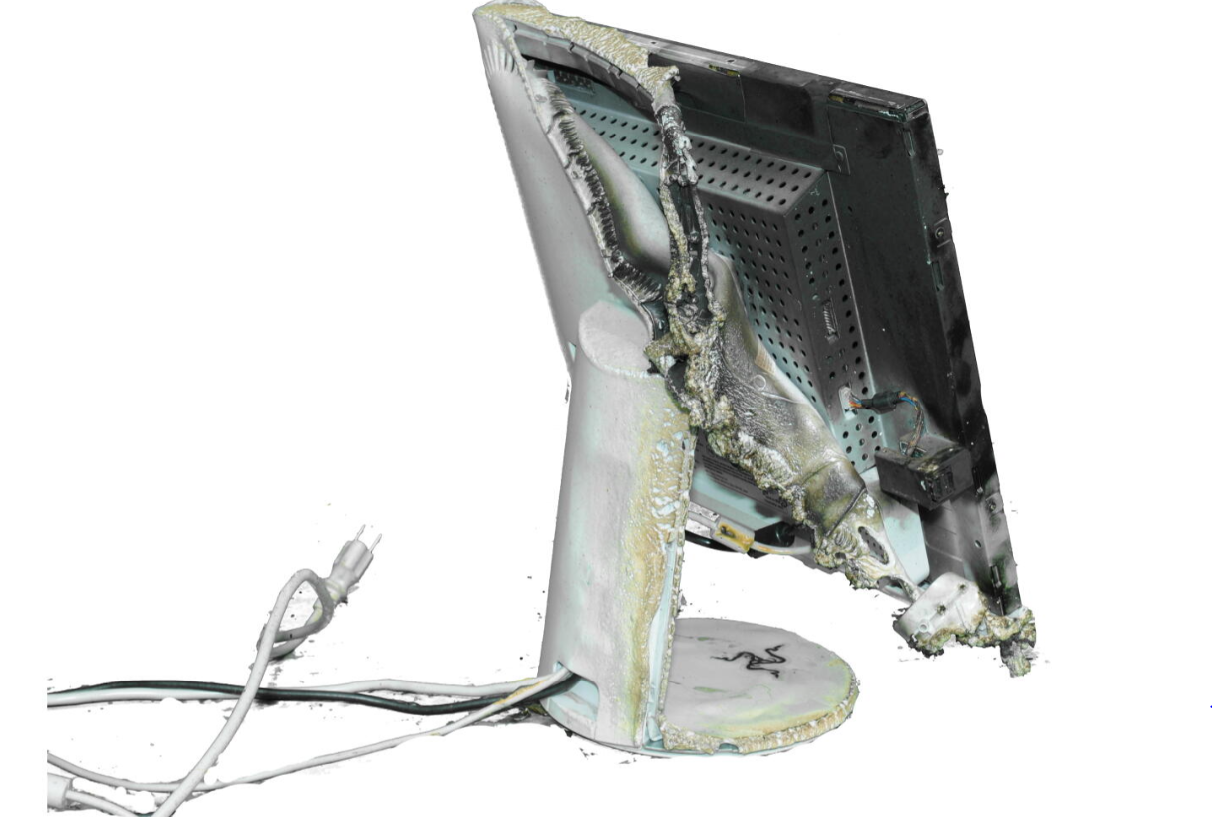
- In your own words describe what spoliation of evidence is, and how it can affect fire investigations. Provide an example of spoliation.

- What is “expectation bias” and how can it impact a fire scene examination? What can be done to avoid it?

- You are asked to investigate the garage fire in the photo below. What are your immediate concerns and how would you eliminate them? Who would you interview, what questions would you ask, and when would you conduct the interviews?
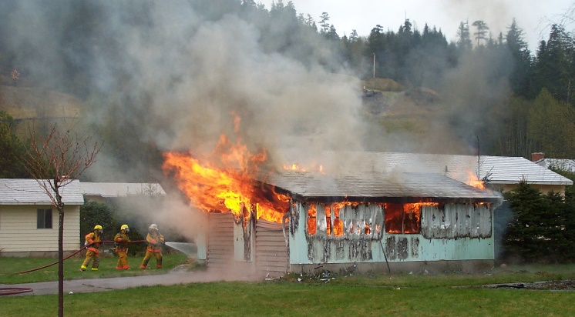

20. As a fire investigator you may be asked to conduct a peer review of another fire investigator’s report. Review the fire report at download the report under the Materials Tab, make your edits and suggestions and upload your final review in the online course assignments: Julie where do they find it?
- Evaluate the report for completeness. thoroughness, grammar, and typographical errors.
- identify areas where further investigation is required.
- Document any discrepancies found in the report.

Part 2
Part 2 involves investigating a 360-degree video fire scenario. A tutorial video is available showing how to use the 360- degree video tools at this LINK as well as in the online course lesson. Make sure you review the tutorial video before conducting the investigation. You may want to do this several times.
Background Information.
You received a call at 09:00 hours from your dispatch center and are given the following information:
There was a kitchen fire in a home at 2785 Main Street, Campbell Hill. The fire department got the call on today’s date at 00:30 hours from a member of the Campbell Hill Police Department, Constable John Nighthawk. Campbell Hill Fire Department responded, and the Incident Commander (IC) was Captain Dennis Wett.
The fire scene has been secured since the time of the fire.
You are the fire investigator for Campbell Hill Fire Department, and you have been asked to conduct a fire origin and cause investigation.
You arrive on the scene at 10:00 hours today.
Assignment
Using the scientific method of investigation, you are to complete and thoroughly document, the investigation of this kitchen fire. Then write a technical report on your findings. The technical report format used in Part 1 Question 20 can be used as a template or you can use the technical report format approved by your agency.
If you want to use the Fire Investigation Field Form to record your investigation prior to writing your technical report, a copy is available under the Materials tab..
Your documentation should include any notes, photographs, sketches, and evidence samples that you identified and used to investigate the fire. Your notes must be transcribed into a typed format. Documents that are not legible will not be graded or contribute to your score in this exercise.
You can access the fire you are to investigate at this LINK
When you have completed your investigation and written your report, move on to Part 3 of this assignment.

Part 3
Prepare a comprehensive PowerPoint or Google Slides presentation (20 minutes maximum) detailing your investigation process and findings. A sample presentation can be found in the Materials tab.
Your PowerPoint/Google Slides presentation must be submitted to the evaluator along with the rest of this assignment. You will be asked to present your PowerPoint presentation virtually, during your online meeting with the evaluator.

Final Steps
After completing the assignment save it on your computer as well as upload online in the step Three lesson. The evaluator will review the assignment and respond with questions or comments. When satisfied with your assignment the evaluator will ask you to make an appointment for a virtual one-on-one interview using shared computer screens that will begin with you presenting your PowerPoint/ Google Slides presentation followed by a question-and-answer period.

