**Fire Inspector Level 1 Hand-in Assignment**

Participant Notes:

This is an assignment that must be completed prior to writing your proctored final exam.

This assignment is divided into three parts. Part 1 is an exercise using the National Fire (NFC) and the National Building (NBC) Codes of Canada.

Part two is a virtual fire inspection of a fire hall utilizing 360-degree photography so you can conduct an inspection of a building online.

Part three is general questions.

You will require:

* online access to the NBC and NFC which is available in the Materials section of the online course.
* a printer (if needed)
* a calculator

***Step 1:*** *Start by filling in your name below and then print off the floor plan of the building, which can be found on the last page of this document, and then answer the following questions by filling in the text box provided.* E.g. Click or tap here to enter text.

**Student name:** Click or tap here to enter text.

**Part 1**

1. Based on the floor plan provided, the Building Code occupancy classifications are ___________.

A2 and F2

A2 and D

A3 and F1

F2 and A3

1. What are the Building Code requirements for fire separation between the occupancies?

¾ hr

1 hr

1 ½ hrs

2 hr

1. How many fire separation doors are required between the occupancies based on the fire separation outlined in blue on the floor plan?

5

4

3

2

1. Calculate the occupant load for the Meeting Room portion of the building based on the maximum load permitted by the NFC and a net floor area of 185.7 m2.

464

309

250

74

1. Calculate the available exit capacity for the Meeting Room allowed by the Building Code using the two double exit doors leading directly out of the building. Each door leaf is 762 mm. and stairs are not involved. Show your calculation formula below.

Click or tap here to enter text.

1. What fire protection equipment is required in the building based on the occupancy classifications and maximum permissible occupant load? Highlight the correct answer and identify the building or fire code reference that supports your answer.

**Question Answer Code Reference**

**Yes No** Ie. NFC 2.2.1. 4 & NBC 3.2.3.1

1. Emergency lights   Click or tap here to enter text.
2. Exit signs   Click or tap here to enter text.
3. Fire alarm system   Click or tap here to enter text.
4. Fire Safety Plan   Click or tap here to enter text.
5. Portable fire extinguishers   Click or tap here to enter text.
6. Occupant load signs   Click or tap here to enter text.
7. Self-closing devices   Click or tap here to enter text.
8. Panic Hardware   Click or tap here to enter text.
9. Sprinkler system   Click or tap here to enter text.

1. What is the required fire resistive rating of the doors (closure) between the apparatus bays and the assembly occupancies?

¾ hr

1 hr

1 ½ hrs.

2 hr

1. The lounge has a net floor area of 20.5 m². What is the maximum occupant load based on net floor area? Show your calculation formula below.

Click or tap here to enter text.

1. Is an occupant load sign required for the lounge? What is the fire code reference that addresses this?

Yes

No

Code Reference: Click or tap here to enter text.

1. Are self-closing devices required on the exit doors from the meeting room? If so, what is the NBC code Reference?

Yes, NBC Division B 3.1.8.13

No, NBC Division B 3.1.8.13

Yes, NBC Division B 3.4.6.13

No, NBC Division B 3.4.6.13

1. There is a janitor’s room off the kitchen. Is the janitor room required to be fire separated? If yes, what clause of the NBC applies?

Yes

No

Code reference: Click or tap here to enter text.

1. Does the Janitor room require a fire detector? If yes, what article of the NBC applies?

Yes

No

Code reference: Click or tap here to enter text.

**Part 2 – Fire Hall Virtual Inspection**

You are now ready to start a virtual inspection of a fire hall using 360 - degree video technology. If you are unfamiliar with 360-degree video technology, click on the following link for a tutorial.

<https://www.youtube.com/watch?v=rJZTpZ1vw2c>

When you are ready, start the 360-degree presentation by clicking on the link below.

<https://my.matterport.com/show/?m=KcpG9WrVAsb>

It is a given that you have conducted a 360-degree tour of the outside of the building and have not identified any deficiencies.

Begin your fire inspection by entering the electrical room from outside the building. Identify and document fire safety deficiencies in point form in the space provided below each heading. Include all deficiencies even if you have recorded them in another section of the report.

**Electrical Room**

Click or tap here to enter text.

**Apparatus Bay and Associated Rooms**

The area in the apparatus floor has limited access via the 360- degree camera. Your focus should be on the access and egress man doors and on the storage and service areas.

Click or tap here to enter text.

**Lounge Area**

Click or tap here to enter text.

**Kitchen**

Click or tap here to enter text.

**Janitor Room- off kitchen**

Click or tap here to enter text.

**Meeting Room**

Click or tap here to enter text.

**Other Deficiencies**

Click or tap here to enter text.

**Part 3**

**Question 3-1**

1. You inspected a building in your community and a few months later it was involved in a fire that resulted in a significant dollar loss. You have been subpoenaed to court to testify about the fire safety of the building at the time of your inspection.

The deficiencies you identified during your inspection included:

* The fire separation door between the ground floor and the floor above did not close and positively latch.
* The fire alarms system was in trouble mode and is past due for annual inspection, testing, and maintenance.
* Emergency lights had no record of inspection.
* Portable fire extinguishers were overdue for annual inspection, testing, and maintenance.

1. Using point form where possible, briefly explain the preparations you would make before appearing in court:

Click or tap here to enter text.

1. How would you present yourself and effectively communicate while appearing in court?

Click or tap here to enter text.

**Question 3-2**

Using point form where possible, briefly explain when a building permit is required?

Click or tap here to enter text.

**Question 3-3**

You are inspecting a fire sprinkler system and see the gauges shown in the photos below.

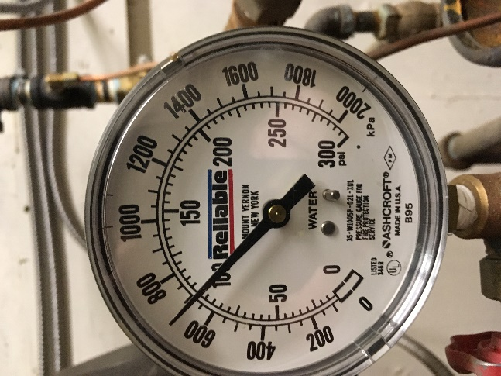 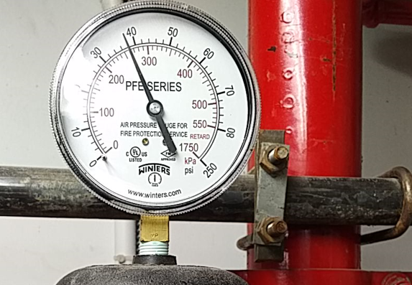

A What type of sprinkler system is it?

Click or tap here to enter text.

B. Briefly explain the variation in the pressure reading between the gauges.

Click or tap here to enter text.

C. When any portion of a sprinkler system is temporarily shut down, what alternative measures shall be taken to ensure that protection is maintained?

Click or tap here to enter text.

NFC Code Reference Click or tap here to enter text.

D. Article _____________ of the National Fire Code states “Where tests, repairs, or alterations are made to fire protection installations, including sprinkler and standpipe systems, a procedure or notification shall be established”. Who should be notified?

Click or tap here to enter text.

Congratulations, you have finished the hand in assignment. Please send it to the College of the Rockies evaluator.

