Student Hand-in Assignment 1

Student Name:
Date:

Answer the following questions:
- What are the steps in a scientific fire investigation?

- What are the stages of fire development?

- Fill in the blanks. To create flaming combustion of a solid fuel, heat must be applied to the fuel to generate flammable vapors through either ___________________ or __________________.

- What is meant by the term “fuel-controlled fire”?

- What stage of fire is reached in this photograph?

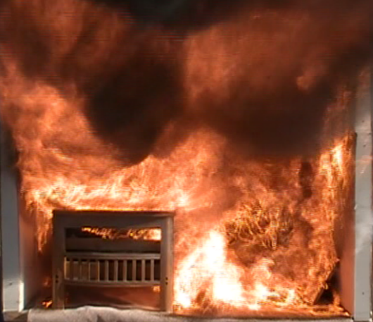

- Describe the fire development seen in the photograph below.
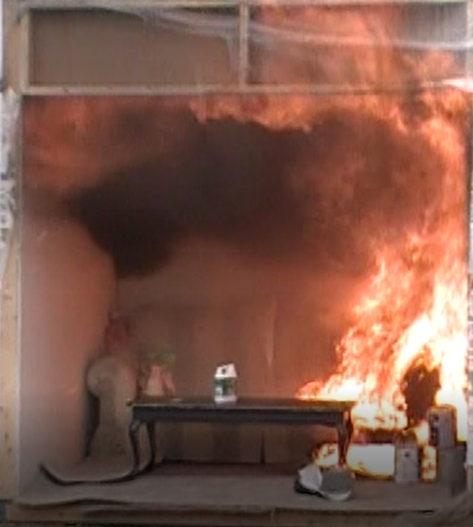

- Based only on this photograph, what is the direction of fire travel? Explain your answer by describing the fire and heat indicators visible in the photograph. You may insert graphics to highlight your response.

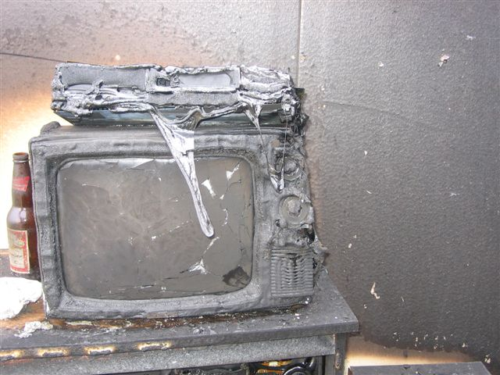

- What type of fire pattern is shown in this photograph and what would cause it? If you found it in a fire scene, what further action would you take?

- You are asked to investigate this fire scene and are told there is a body in the room seen in the lower left side of the photo below.
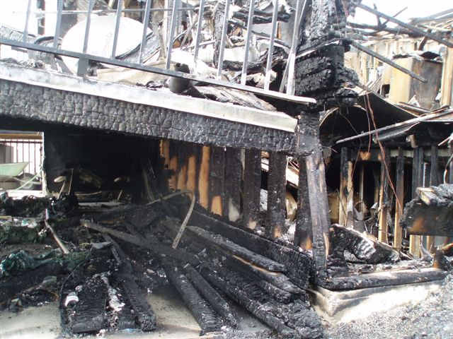

Answer the following questions.
Q. Who has statutory responsibility to investigate this fire and what is their role?
Q. In point form, note what actions you would take to investigate the fire.

- Based only on the photograph below, describe the visible fire patterns, what caused them, and where you think the fire started. What stage of fire was reached in this compartment?

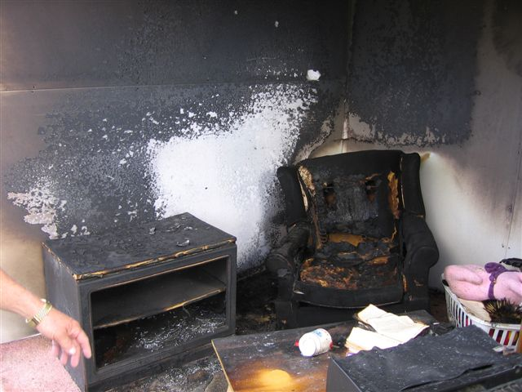

- An elderly man received serious burns resulting from the house fire seen in the photograph below. He is currently in intensive care at the burn unit and is unlikely to survive. You have been assigned to investigate the fire, which may take several days. Describe the methods of security you would use to ensure continuity of the scene. Describe all instructions you would give to security personnel.
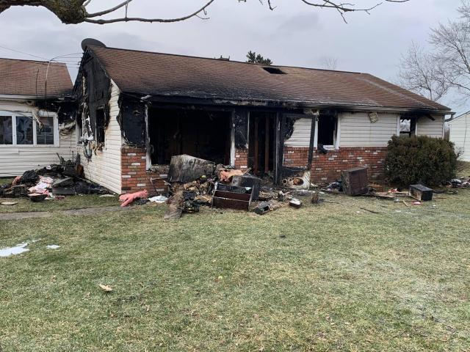

- While conducting a 360-degree external survey of the scene you find a plastic container containing an unidentified liquid. What action would you take?

- You are assigned to investigate a fire and explosion at the home in the 3 photographs below.
Photo #1
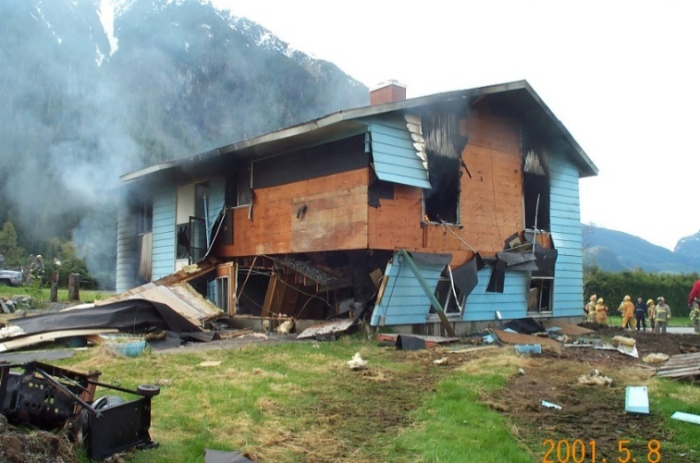
Photo #2
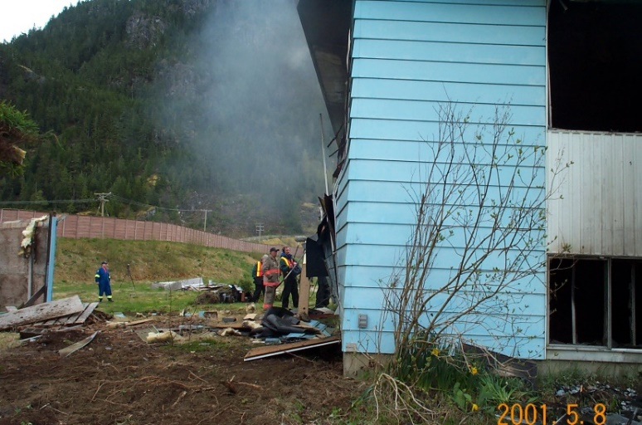
Photo #3
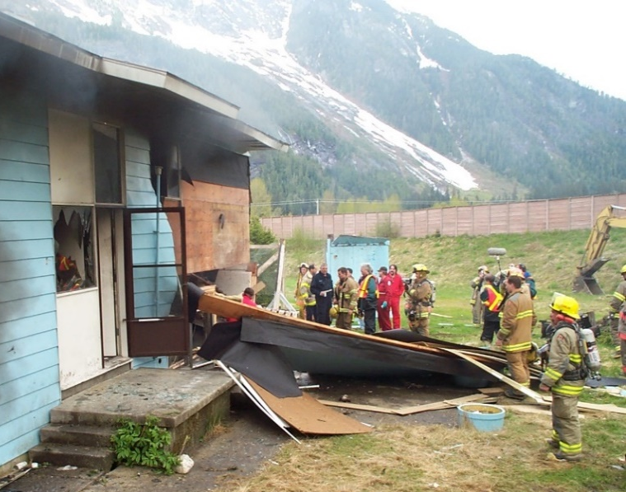
Based on these photographs, describe:
- the type of explosion that took place.
- the explosive effects on the building
- where the blast originated
- possible causes of the explosion
- if this is high or low-order damage

- During a fire scene examination, you identify a “V” shaped burn pattern on a wall like the one in this photograph. How will you preserve this as evidence?
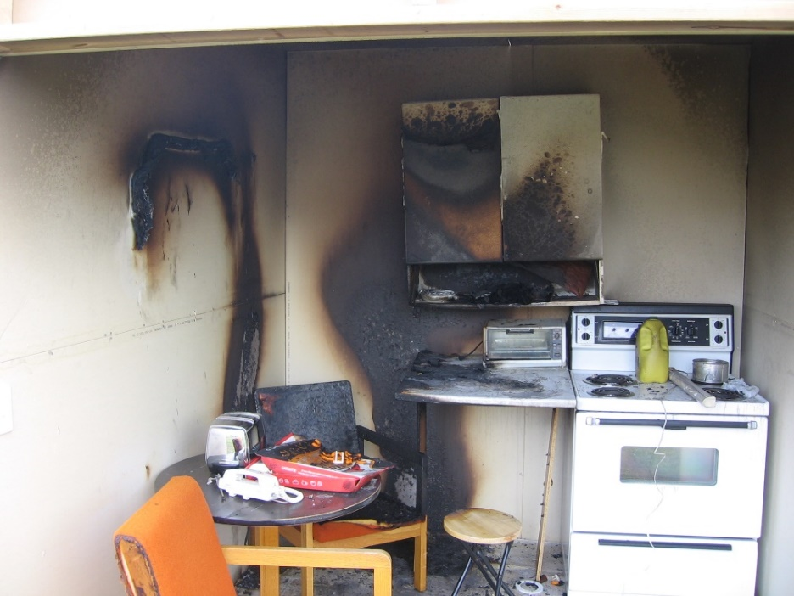

- During an investigation, you find the remains of a plastic container in the area of origin of the fire. How would you process this evidence in line with the practices and legal requirements of your jurisdiction? If you are sending it to a lab for analysis, fill out the Forensic Lab Submission form that can be found in the Materials Section.
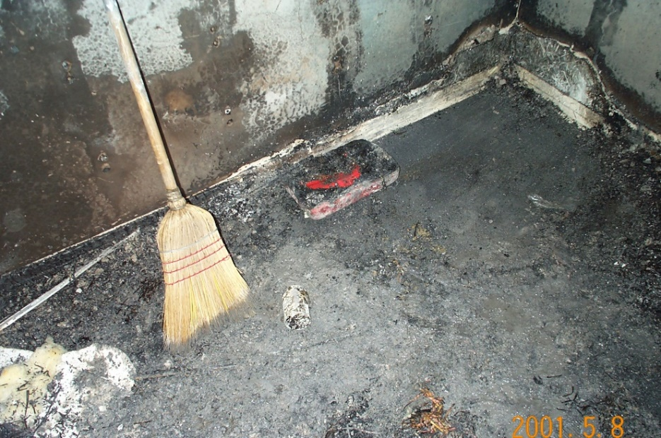

- As part of the initial fire investigation, you determined that the video monitor in the photograph below may have failed, so you secured it as potential evidence. After your investigation is complete, you determine that the damage to the monitor is the result of the fire, not the cause of the fire. How would you dispose of it?

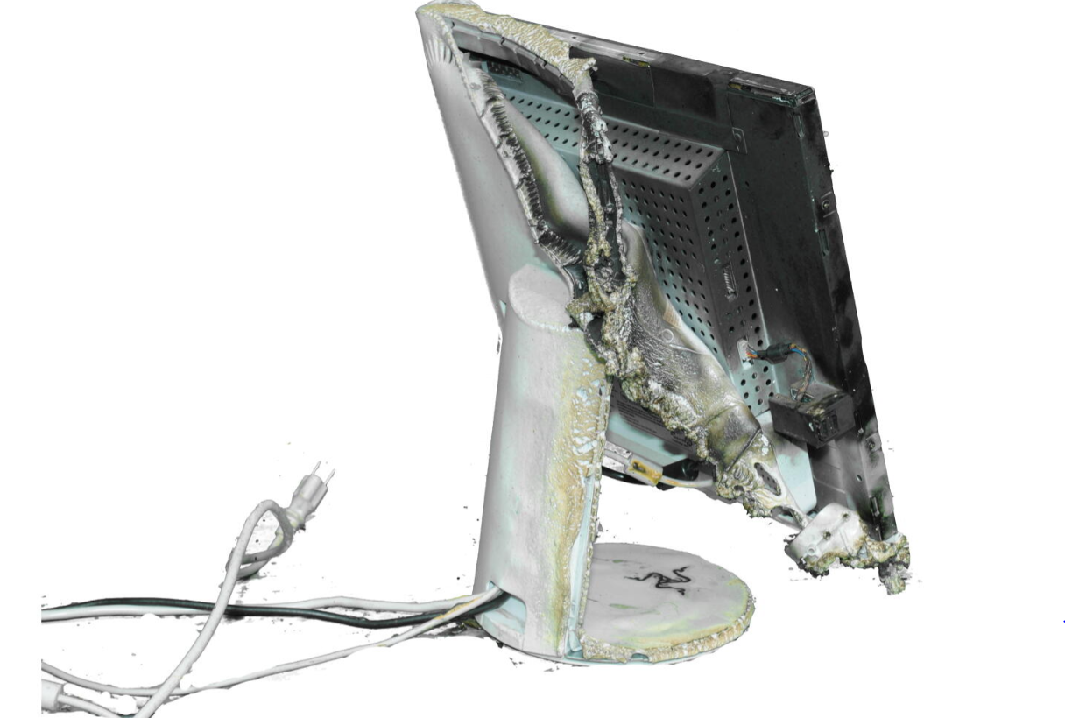
- In your own words, describe what spoliation of evidence is and how it can affect fire investigations. Provide an example of spoliation.

- What is “expectation bias” and how can it impact a fire scene examination? What can be done to avoid it?

- You are asked to investigate the garage fire in the photo below. What are your immediate concerns and how would you eliminate them? Who would you interview, what questions would you ask, and when would you conduct the interviews?
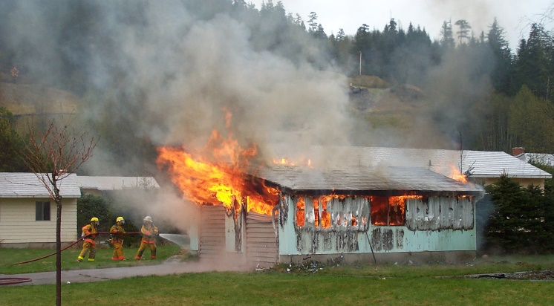

20. Describe four generally recognized categories of evidence that you may encounter at a fire scene or in a legal proceeding and give examples of each type.

