**Fire Inspector Level l & II Hand-in Assignment**

Participant Notes:

This is an assignment that **must be** emailed to the College of the Rockies Evaluator prior to writing your exam and doing your virtual inspection online with an evaluator. Handwritten assignments will not be accepted without prior consent from the COTR Evaluator.

This assignment is divided into three parts. Part 1 is an exercise using the National Fire Code (NFC) and the National Building (NBC).

Part two is a virtual fire inspection of a fire hall utilizing 360-degree photography so you can conduct an inspection of a building online.

Part three involves additional code work.

You will require:

* online access to the NBC and NFC
* a printer
* a calculator

***Step 1:*** *Start by filling in your name below and then print off the floor plan of the building, which can be found on the last page of this document, and then answer the following questions by filling in the text box provided.* E.g. Click or tap here to enter text.

**Studentname:** Click or tap here to enter text.

Email address:

Phone number:

**Part 1**

1. Based on the floor plan provided, the National Building Code (NBC) major occupancy classifications are?

Click or tap here to enter text.and Click or tap here to enter text.

1. What is the fire resistive rating required by the NBC between the major occupancies?

Click or tap here to enter text.

1. What table in the NBC identifies the minimum fire resistive rating required between major occupancies?

Click or tap here to enter text.

1. How many fire separation doors are required between the major occupancies based on the fire separation outlined in blue on the floor plan?

Click or tap here to enter text.

1. What is the required fire resistive rating of the doors between the apparatus bays and the assembly occupancies?

Click or tap here to enter text.

What code reference applies?

Click or tap here to enter text.

1. Calculate the occupant load for the Meeting Room portion of the building based on the maximum load permitted by the NFC and a net floor area using the measurements shown on the drawing.

Show your calculation equation below.

Click or tap here to enter text.

1. What code reference applies to the maximum permissible occupant load calculation?

Click or tap here to enter text.

1. Calculate the available exit capacity for the Meeting Room allowed by the National Building Code using the two double exit doors leading directly out of the building. Each door leaf is 762 mm and stairs are not involved. Show your calculation equation below.

Click or tap here to enter text.

1. What is the fire code reference that addresses the need for occupant load signs?

Click or tap here to enter text.

1. What fire protection equipment is required in the building based on the occupancy classifications and maximum permissible occupant load? Select the correct answer, yes or no, and identify the building or fire code reference that supports your answer.

**Question Answer Code Reference**

Yes No Ie. NFC 2.2.1. 4 or NBC 3.2.3.1

1. Emergency lights   Click or tap here to enter text.
2. Exit signs   Click or tap here to enter text.
3. Fire alarm system   Click or tap here to enter text.
4. Fire Safety Plan   Click or tap here to enter text.
5. Portable fire extinguishers   Click or tap here to enter text.
6. Occupant load signs   Click or tap here to enter text.
7. Self-closing devices   Click or tap here to enter text.
8. Panic Hardware   Click or tap here to enter text.
9. Sprinkler system   Click or tap here to enter text.
10. Are self-closing devices required on the exterior exit doors from the meeting room? If so, what is the NBC code reference?

Yes No  Code Reference Click or tap here to enter text.

1. There is a janitor’s room off the kitchen. Is the janitor room required to be fire separated?

Yes  No  Code Reference: Click or tap here to enter text.

1. Does the Janitor room require a fire detector?

Yes  No  Code Reference: Click or tap here to enter text.

**Part 2**

You are now ready to start a virtual inspection of a fire hall using 360 - degree video technology. If you are unfamiliar with 360-degree video technology, click on the following link for a tutorial.

Tutorial: <https://www.youtube.com/watch?v=rJZTpZ1vw2c>

**Start the 360-degree presentation by clicking on the link below.**

<https://my.matterport.com/show/?m=KcpG9WrVAsb>

It is a given that you have conducted a 360-degree tour of the outside of the building and have not identified any deficiencies.

Begin your fire inspection by entering the electrical room from outside the building. Identify and document fire safety deficiencies in point form in the space provided below each heading. Include all deficiencies even if you have recorded them in another section of the report.

**Electrical Room** (identify any deficiencies in point form below)

Click or tap here to enter text.

**Apparatus Bay and Associated Rooms**

The area in the apparatus floor has limited access via the 360- degree camera. Your focus should be on the access and egress main doors and on the storage and service areas.

Click or tap here to enter text.

**Lounge Area**

Click or tap here to enter text.

**Kitchen**

Click or tap here to enter text.

**Janitor Room- off kitchen**

Click or tap here to enter text.

**Meeting Room**

Click or tap here to enter text.

**General Comments**

Click or tap here to enter text.

**Part 3**

1. You are inspecting a two-story mixed-use building with commercial space on the ground floor and five residential apartments and a dance studio on the second floor, as shown below.

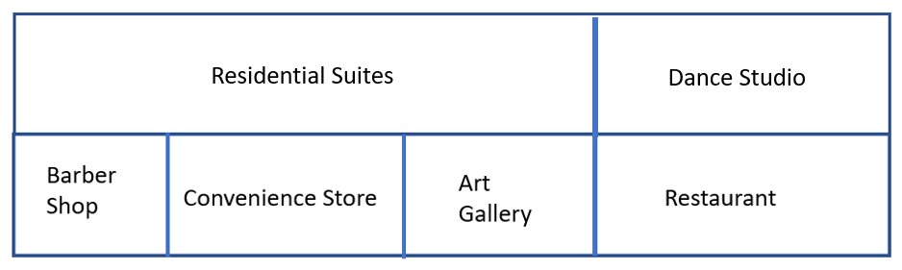

What fire separation is required between:

* the Art Gallery and the Restaurant? Click or tap here to enter text.
* the residential suites and the dance studio Click or tap here to enter text.
* the convenience store and the barber shop Click or tap here to enter text.
* the convenience store and the residential suites Click or tap here to enter text.

1. The building is equipped with an NFPA 13 fire sprinkler system. While performing your inspection the air compressor comes on. The building representative that is accompanying you on the inspection tells you that the air compressor comes on five or six times a day.
2. What type of sprinkler system is installed?

Answer: Click or tap here to enter text.

b. Does the frequency of the compressor activation indicate a problem with the sprinkler system?

Answer: Yes  No

1. Briefly define in point form the possible causes for the air compressor to run frequently.

Click or tap here to enter text.

1. What edition of NFPA 13 applies in this situation?

Click or tap here to enter text.

1. Article Click or tap here to enter text. of NFPA 13 states:

“Any leakage that results in a loss of air pressure in excess of Click or tap here to enter text.in a Click or tap here to enter text.hour period shall be corrected.”

1. Based on the drawing below, calculate the occupant load for the second floor of the building based on the five two-bedroom residential suites and a maximum occupant load permitted in the dance studio by the NFC and the NBC restriction on door capacity. The dance studio door is 914mm.

Show your calculation and the applicable NBC and NFC code reference(s) below.

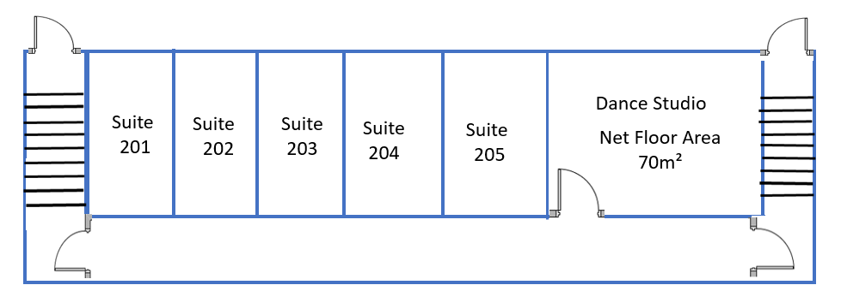

Click or tap here to enter text.

1. You have identified what you perceive to be a problem with the NFC and want to make a code change proposal to the National Research Council (NRC). In point form below, briefly describe the steps you would take to initiate a code change proposal.

*Student Note: This will require some research of external material not provided in this course*.

Click or tap here to enter text.

Congratulations, you have finished the hand in assignment. Please send it to the College of the Rockies evaluator.

The building footprint is 960 metres squared.