Canadian Centre for Occupational Health and Safety
Portable Fire Extinguishers – Fact Sheet

What is the fire tetrahedron?
To understand how to prevent fires, it is important to know how a fire can occur. Four elements must be present at the same time for a fire to take place:

Fuel or combustible material - something to burn, such as paper or wood.
Heat - to raise the material to its ignition (burning) temperature.
Oxygen - to sustain combustion (the fire).
Chemical reaction - the process of burning.
If you remove any of these four elements, the fire will not be able to burn.

What should I know about fighting fires?
Never fight a fire if:
You do not know what material is burning.
You do not know what type of fire extinguisher to use.
You do not know how to use the fire extinguisher.
The fire is spreading beyond the spot where it started.
Your instincts tell you not to.
If you are not confident about your ability to handle the situation (even if you are trained in fire fighting), or if you do not have the correct type of fire extinguisher, do not fight the fire. Pull the fire alarm, evacuate the area, and then call the fire department.

What are the different classes of fires?
Fires are grouped into classes which depend on the material or substance that is present.

Class A - Fires involving ordinary combustibles such as paper, wood, cloth, rubber, or plastics.
Class B - Fires involving flammable or combustible liquids, gases, oil, paints, or lacquer.
Class C - Fires involving energized (live) electrical equipment such as motors, appliances, or power tools.
Class D - Fires involving combustible metals such as magnesium, titanium, sodium, and potassium.
Class K - Fires involving combustible cooking oils, or fats in cooking appliances.

What are the different types of portable fire extinguishers?
To fight the different classes of fires, there are different types of fire extinguishers. Each has its own characteristics, capabilities, and limitations.

Three main types of portable fire extinguishers include:

Water extinguishers: Water extinguishers are filled about two-thirds with water and then pressurized with air. When used for Class A fires, these extinguishers remove the heat from the burning materials.

Do not use water to extinguish an electrical fire. Water is a good conductor and can increase the possibility of electrocution.
Do not use water to extinguish flammable liquid or cooking oil fires. Water is ineffective as it helps to spread the liquid and the fire.
Carbon Dioxide (CO2) extinguishers: The extinguishing media is pressurized CO2. When used for Class B and C fires, the CO2 covers the fuel by blanketing it, and stops the reaction at the surface by displacing oxygen. Be thorough when using a CO2 extinguisher. It has a moderate spray range and last only 10 to 30 seconds. A hard horn attached to the end of the spray tube helps to contain and aim the spray at the target area.

Do not use CO2 extinguishers in confined spaces as CO2 can displace the oxygen in the air, making breathing difficult. Only use in a confined space if workers have appropriate respiratory protection.
Do not use CO2 extinguishers for Class A fires because the fire may continue to smolder and re-ignite after the CO2 disperses.
Dry Chemical extinguishers: Dry chemical extinguishers are the most common and available in few types. These extinguishers will be marked for the classes they are designed to extinguish (e.g., ABC type extinguisher will put out Class A, B and C fires). The extinguishers discharge a blanket of fine powder which creates a break between the fuel and the oxygen in the air. The powder also works to break the chemical reaction. Be accurate when using as they have a short to moderate spray range and last only 10 to 25 seconds.

Be cautious of the residue after using dry chemical extinguishers. The residue can damage motors, computers and other electrical equipment.

Below is a summary of these and other common extinguishers.
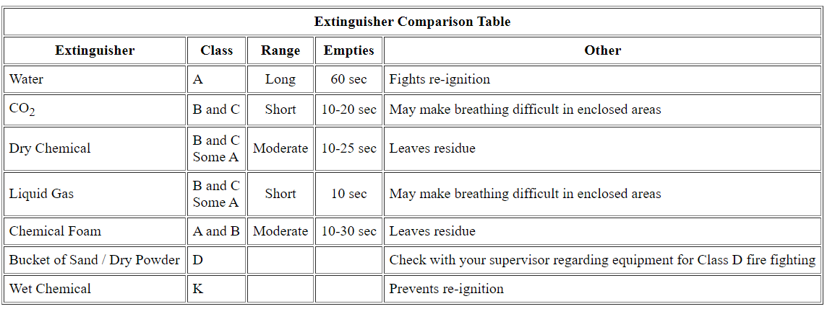

How will portable fire extinguishers be marked?
Portable fire extinguisher may use the following markings to indicate which class of fire they are designed to fight. These symbols are recommended by the National Fire Protection Association (NFPA) in the USA. The symbols may be shown using colours.

What you should know when using a portable fire extinguisher?
Always:
Be sure that you are trained to use a fire extinguisher before you try to fight a fire.
Know what type (class) of material is burning.
Use the correct fire extinguisher type to fight the fire.
Remember, if you feel that you cannot safely extinguish the fire using the portable extinguisher available and if you have not already done so, pull the fire alarm, evacuate the area, and then call the fire department.
When using an extinguisher, use the PASS system - Pull, Aim, Squeeze, Sweep.
Pull the pin on the extinguisher.
Aim the extinguisher.
Squeeze the trigger or top handle.
Sweep the fire area with the extinguisher’s spray until the fire is completely out.
For floor fires, sweep from the edges in. For wall fires, sweep from the bottom up.
Never walk away from a fire, even if you think it is out. The residue may reignite.
Always stand between the escape route and the fire so you can leave safely if the fire grows.
If the fire grows too large, leave the area. Activate the fire alarm to evacuate the area.

What you should know about selecting, locating, and maintaining portable fire extinguishers?
As an employer/contractor, you must:
Use the proper size of extinguisher.
Install extinguishers according to the height requirements stated in your jurisdiction’s Fire Code.
Locate extinguishers so they are readily accessible to employees for immediate use.
Make sure that extinguishers are clearly visible, and any location signs are clear.
Mark or label all fire extinguishers clearly with the class of fire it is to be used for.
Make sure that the operating instructions always face outward.
Maintain extinguishers in a fully charged and operable condition.
Keep extinguishers in the designated places at all times (except during use).
Visually inspect portable fire extinguishers monthly.
Use a tag on each extinguisher that shows the dates of inspection, recharging or servicing, the name of the servicing agency, and the name of the person who did the service.
Service portable fire extinguishers at least once a year, or when the monthly inspection indicates servicing is necessary.
Keep written records showing maintenance items such as serial number and type of extinguishers, location, inspection date, description of tests, date of next inspection, date of annual servicing, comments and inspector’s signature.
Only allow service by trained persons with suitable testing equipment and facilities.

What are items that may be included in a monthly inspection?
Portable fire extinguishers should be inspected at least monthly. Visually check for the following items. Customize this list for your workplace.
Are the fire extinguishers well supported and hangers are fastened solidly?
Are the fire extinguishers accessible?
Can be easily reached
There are no obstructions
Location signs are clear
Class markings are clear
Operating instructions are clear
Are the extinguishers in good working condition?
Discharge opening is clear
It is fully charged
It has not been damaged or tampered with
Hydrostatic testing has been done
Is the ring pin in place?
Is the seal intact?

When you should remove extinguishers from service?
Extinguishers with the following conditions are should be removed from service:
When the cylinder or shell threads are damaged
Where there is a corrosion that has caused pitting, including corrosion under removable name plate assembles
When the extinguisher has been burned in a fire
Always check with the supplier or manufacturer if you are not sure about the serviceability of the fire extinguisher.

Do portable fire extinguishers require WHMIS labels?
Depending upon what type of extinguisher it is, a fire extinguisher may be classified as a controlled product (under WHMIS 1988) or hazardous product (under WHMIS 2015). Many extinguishers will meet the compressed gas criteria and will therefore require a WHMIS label. Others extinguishers may also be classified in other WHMIS classes due to the physical or health effects of the extinguishing media.

