Apex Inspecting Rack Storage

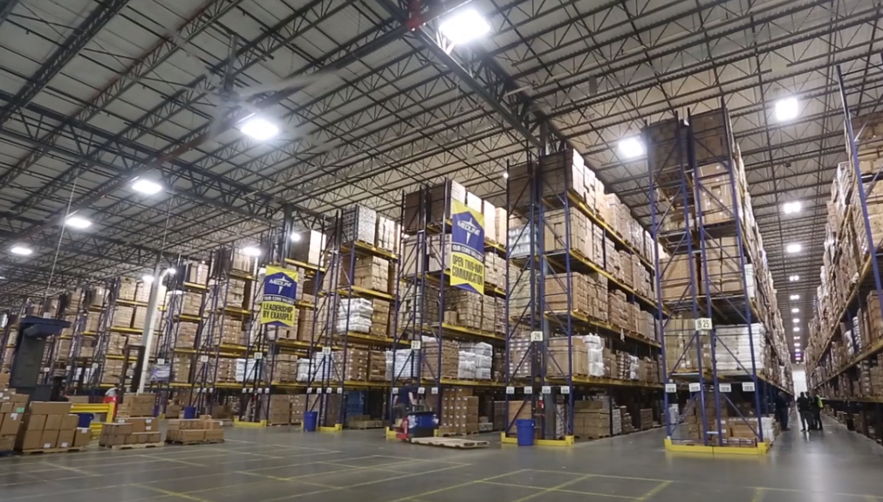

https://www.youtube.com/watch?v=inn9JQaG6og&t=111s in the Additional Resources Section

