STRUCTURE FIRE REPORT

5678 Briar Lane, Green Valley.

INCIDENT #CGV-22-11-06-08-01

Evaluators Note: A list of errors, omissions, and other deficiencies is provided in a table at the end of the document. Most of the errors are noted in red in the body of the report as well.

PREPARED BY: Name

The incident number shown at the top of this page is different than the one shown in the footer

Table of Contents
SECTION 1 INTRODUCTION 3
1.1 Executive Summary 3
SUMMARY OF FINDINGS 3
SECTION 2 BACKGROUND 4
2.1 Objective 4
2.2 History 4
2.3 Fire Scene Description 4
SECTION 3 INVESTIGATION PROCESS 5
3.1 Safety and Orientation 5
3.2 360-Degree Walk Around 5
SECTION 4 CAUSAL FACTORS 10
4.1 Area of Origin 10
4.2 Point of Origin 11
4.4 Material First Ignited 15
SECTION 5 CONCLUSIONS 15
5.1 Act or Omission 15
APPENDIX (A) WITNESS INFORMATION and Interviews 18
APPENDIX (B) INTERVIEWS WITH PARTICIPATING AGENCIES. 20
APPENDIX (C) PHOTOS AND LOG 27
APPENDIX (C) SKETCHES AND DRAWINGS 27

Table of contents requires updating, there are not 27 pages.
4.3 is missing
Witness information starts on page 16

SECTION 1 INTRODUCTION

1.1 Executive Summary

Incident No: CGV-22-11-06-08-01
Date of Report: December 15, 2022
Dispatched: November 6, 2022 | Time: 10:02
Date of Fire November 6, 2022 | Time: 08:05
Investigated by: Samuel Brown | Assigned by: Fire Dispatch
Location of Fire: 5678 Briar Lane | Green Valley
Property Classification: 1 Story Commercial – Business and Personal Services

 | NAME | ADDRESS | TELEPHONE
OWNER | ACME Properties Ltd. | 4478 Shoreline Drive | 404-818- 2400
OCCUPANTS | Green Valley Accounting Services | 5678 Briar Lane | 259-654-2203
Fire Department Personnel
- Incident Commander: Captain Albert Shaw
- Firefighter: Wanda Johnson
- Firefighter: Bill Wakely

Other Agencies Involved
Electrical Safety Authority | Tom Edison | 2121 – 21 Street, Green Valley | 404-765-7654
Brown Brothers Insurance | Amy Steel | #303 – 2234 Stone Hill Place, Green Valley | 404- 765-1191
Mutual Fidelity Insurance | Garth Keyler | #201 – 234 – 6th Street, Green Valley | 404-765-2411

SUMMARY OF FINDINGS

Area of Origin: The Area of Origin was on the inside of the building near the center of the Charlie wall.
Point of Origin: The Point of Origin was near floor level between the easy chair and the filing cabinet near the Charlie wall.
Heat of Ignition: The heat of ignition was an electrical power bar.
Material First Ignited: The Material First Ignited was the plastic shell of the power bar.
Act or Omission: The cause of this fire was undetermined. Act or Omission not consistent with findings in Section 5.1 of this report. 5.1 says accidental.

SECTION 2 BACKGROUND

2.1 Objective

On November 6, 2022, I was assigned by fire dispatch at 09:45 to attend a fire scene at 5678 Briar Lane in Green Valley for the purpose of fire cause determination.

2.2 History

The Fire Department received the call on November 6, 2022, at 08:05 hours. Upon arrival, they found the fire was contained in the office.

The fire department responded with Command 1 and Engine 4. They arrived at 08:12 and Captain Albert Shaw established command.

Captain Shaw told me that he completed a 360 around the building and that the building was secure. His crew forced entry on the Alpha side and easily knocked down the fire.

Captain Shaw called for an investigator because during overhaul he noticed distinct burn patterns that he thought may be electrical in nature. He said, “I did not want to disturb anything before a qualified fire investigator looked at it”.

My complete interview notes with Incident Commander Albert Shaw can be found in Appendix “B”.

2.3 Fire Scene Description

Building Detail:
- 128 square feet wood frame with a shed roof
- Single story, one suite commercial and personal service occupancy
- Baseboard electric heat

Building Sketches:

A rough sketch of the site plan is attached as drawing RS1 in Appendix “D” No site plan provided in the Appendix
A rough sketch of the floor plan and contents can be scene in drawing RS2 in Appendix “DC”. Scene should be seen. Appendix DC should be Appendix D

First Observations:

I arrived on scene at 10:42 on November 6,2022. My first observations upon arrival were that there were two buildings of similar size and construction on the property with two different addresses, 5678 Briar Lane and 5680 Briar Lane. I was assigned to investigate the building at 5678 Briar Lane.
The Incident Commander was waiting for me, and I interviewed him at 10:46 hours. A copy of the interview can be found in Appendix “B” of this report.

SECTION 3 INVESTIGATION PROCESS

3.1 Safety and Orientation
  - I met with and interviewed Incident Commander Albert Shaw and was told that the scene was safe to enter with appropriate personal protective equipment (PPE). The power to the building had been terminated and the meter removed by the utility company.
  - The building is slab on grade and there are no collapse hazards.

3.2 360-Degree Walk Around
I began the scene examination by doing a 360-degree walk around the building exterior starting on the Alpha side and moving clockwise.
There was visible smoke and heat residue from the fire on the Alpha side near the upper level of the building opening, see photograph # 1 below.
Photograph # 1
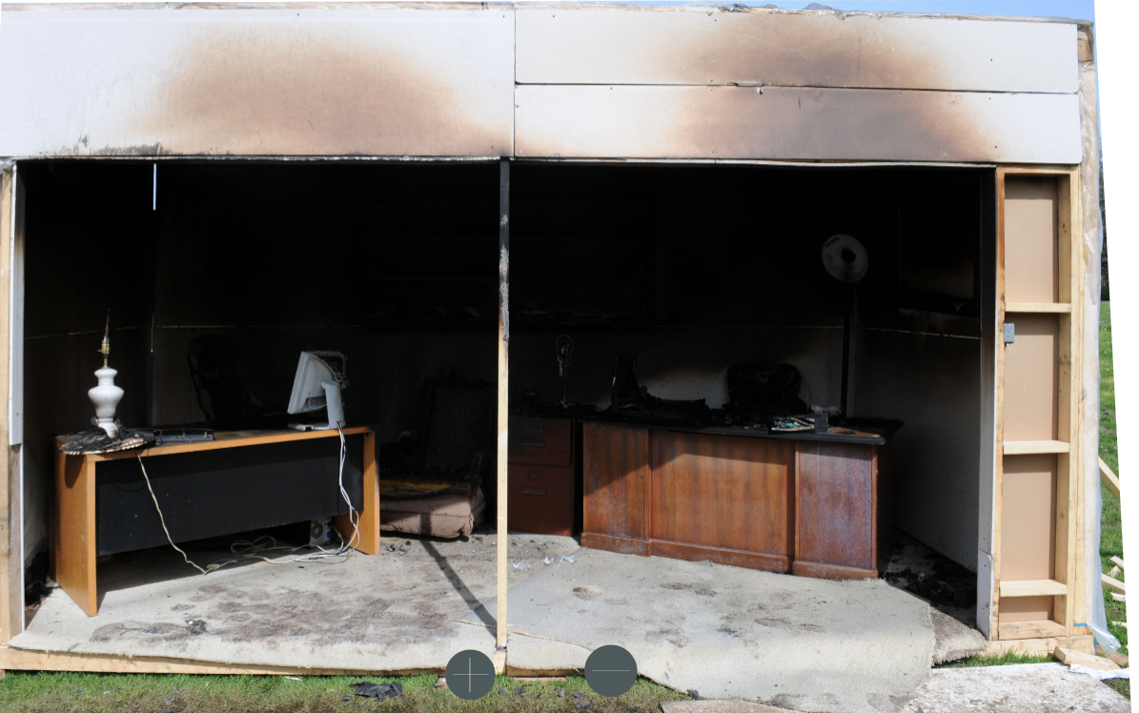

The unburned carpet and the line of demarcation, highlighted by the red line, means that the fire was in the growth stage of development and did not reach the fully developed stage and flash over did not occur.
The only fire indicator on the Bravo side was slight melting of plastic near the Bravo–Alpha corner. Photo?
There was some heat damage on the exterior Charlie wall near ceiling level and near floor level near the center of the wall, see photographs #2 and #3 below.

Photograph #2 shows the damage on the Charlie wall.
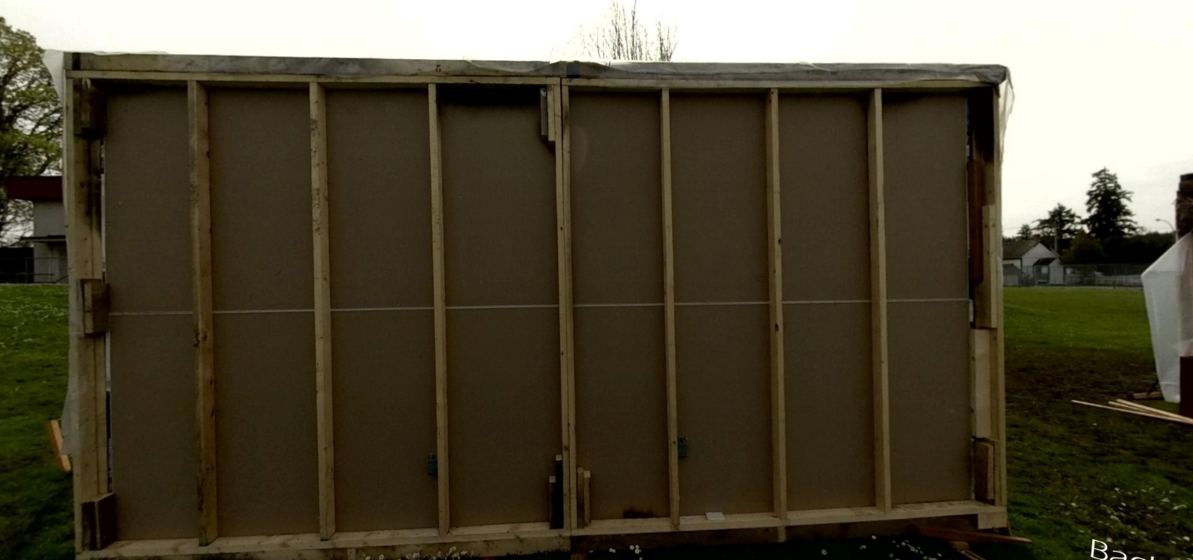

Photograph #3 shows that the fire burned through the exterior side of the wall at floor level near the center of the Charlie wall. The center of the wall is determined by the double studs.
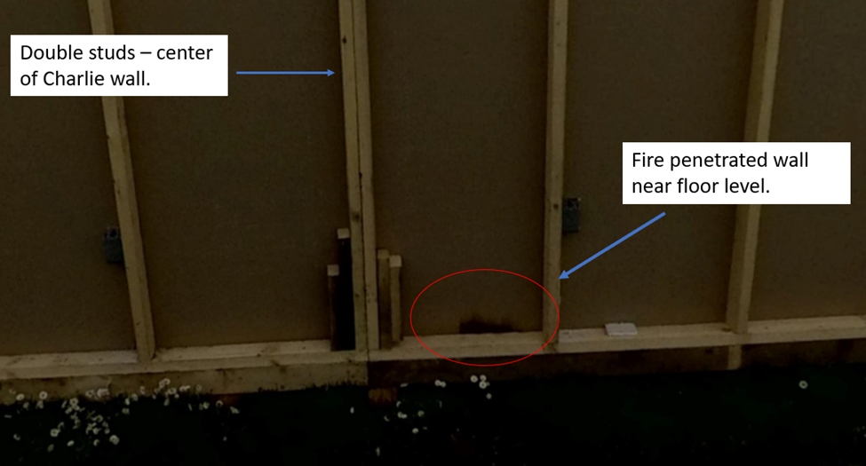

No mention of conditions on the Delta wall
Interior Examination
The interior of the scene was one room filled with typical office equipment and furniture, see photograph # 4 below.
Photograph #4 Inside the office.
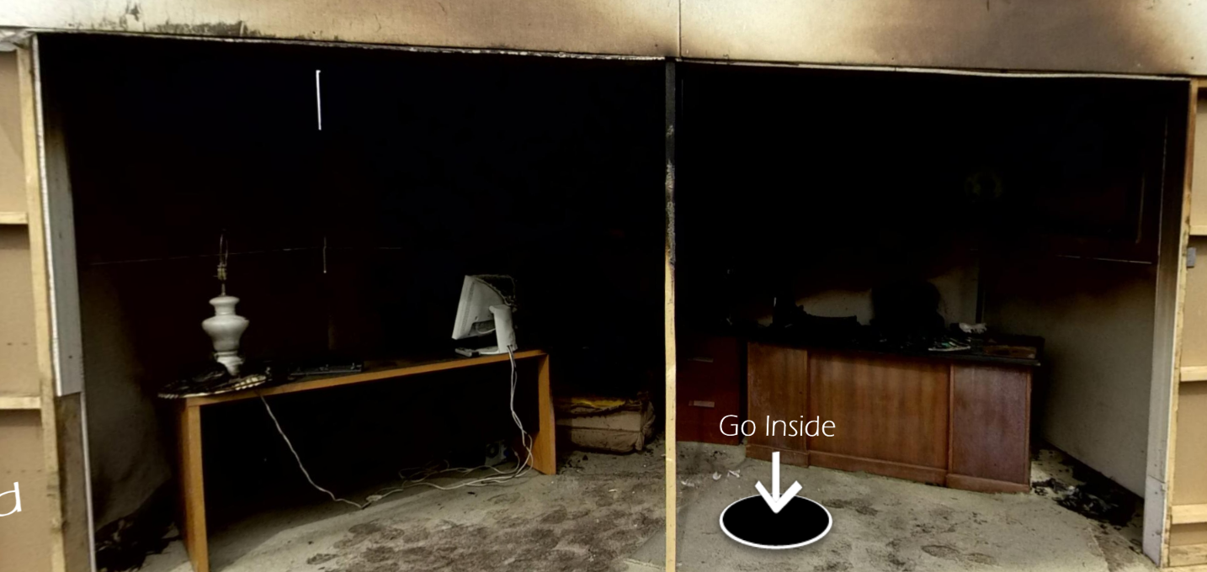
The least fire damage was on the Bravo and Delta sides of the room. Burn patterns indicate that these were the least affected by the fire. Photograph # 5 below, shows the effects from fire and heat damage on the Delta wall were limited to the area above the red line.
Photograph #5.
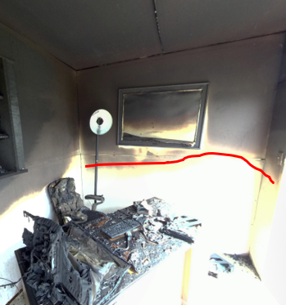

The reason the red line drops down on the Alpha side is the result of flameover and ventilation.

Photograph #6 below shows the burn patterns on the Bravo wall of the building. The burn patterns on the Bravo wall were very light compared with the Charlie wall.
Photograph #6
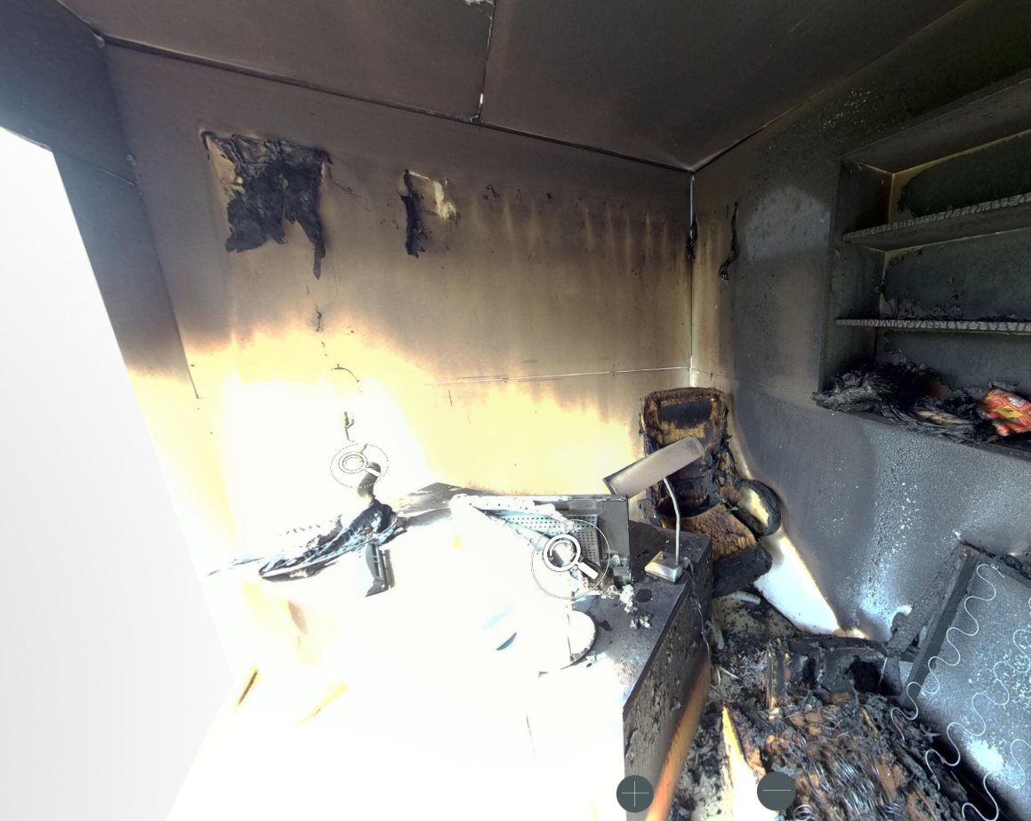
There was a computer monitor on the desk near the Bravo wall that clearly shows the direction of fire travel, see photograph # 7 below.

Photograph #7
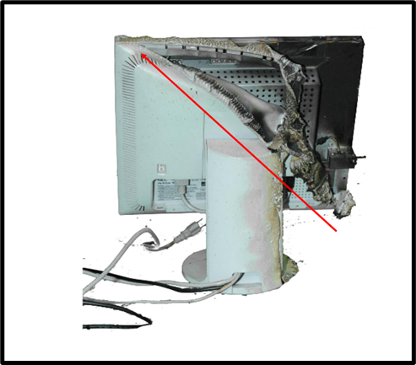

The most extensive fire damage was to office furnishings near the Charlie wall, see photograph # 8 below.
Photograph # 8
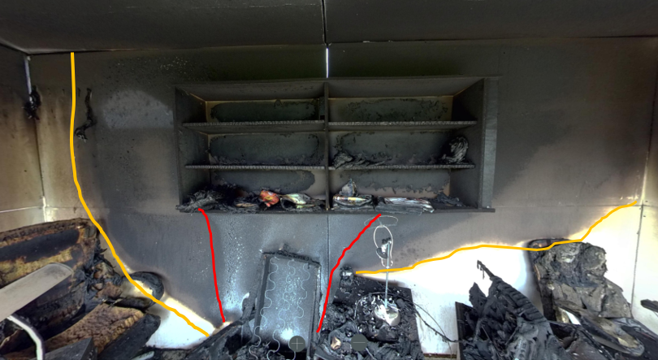
The line of demarcation highlighted in yellow starts at floor level and moves upwards and outwards. This was caused by the heat. A “V” pattern, highlighted in red, was caused by more intense heat and direct flame contact.
Once the furniture had been removed very distinctive burn patterns were evident as can be seen in photograph # 9 below.
Photograph #9
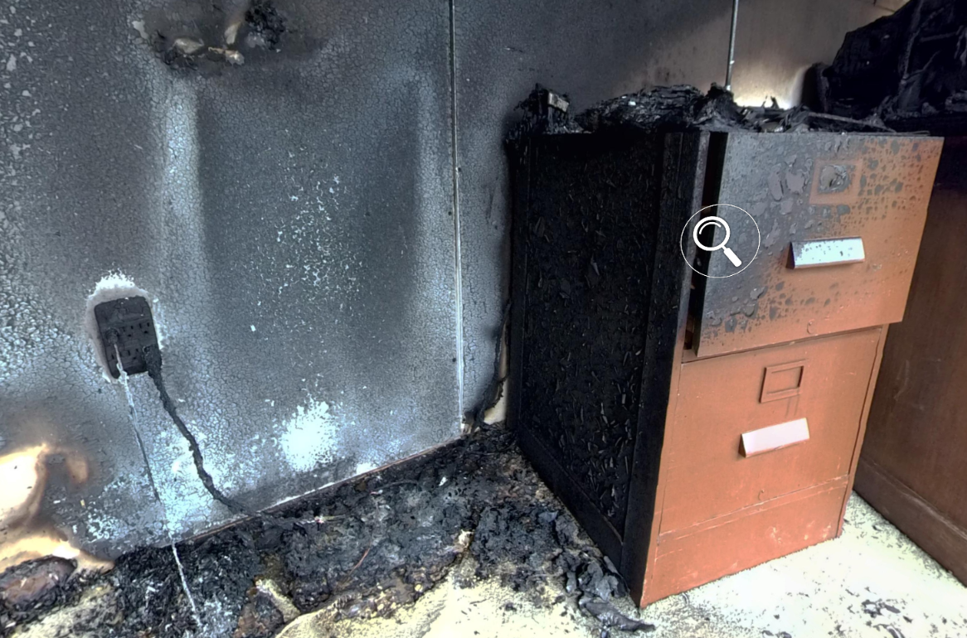

SECTION 4 CAUSAL FACTORS

4.1 Area of Origin

The area of origin of this fire was near the center of the Charlie wall as can be seen in photograph #10 below.

Photograph #10.

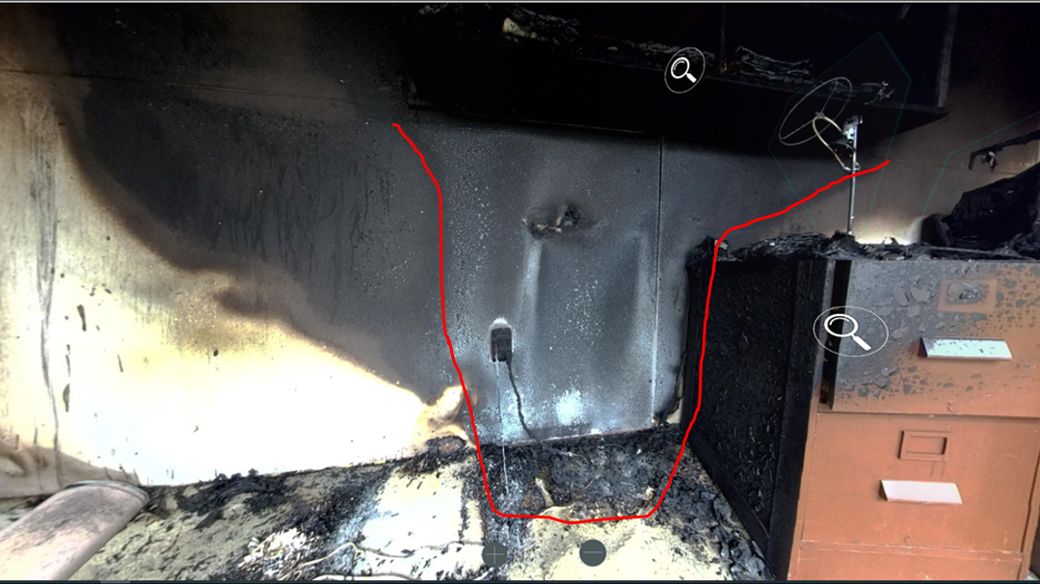

The heaviest burn and most significant charring occurred on Charlie wall and floor on the Bravo side of the two-drawer filing cabinet as outlined in red and seen in photograph #10. This was determined to be the area of origin of this fire based on burn patterns, and the extent of fire damage.

Fire damage away from this area diminished significantly.

4.2 Point of Origin

The point of origin was at floor level on the Bravo side of the 2-drawer filing cabinet as seen in photograph #11 below.

Photograph #11

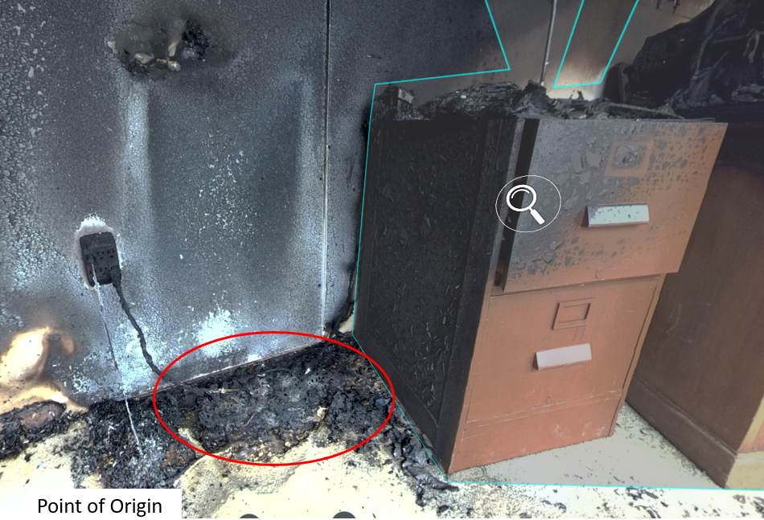

The area inside the red circle was the most heavily damaged area and all the burn patterns emanated from this area.

The clean burn pattern circled in red in photograph #12 below is on the Charlie wall near the point of origin. It was caused by direct flame contact from the fire.

Photograph #12

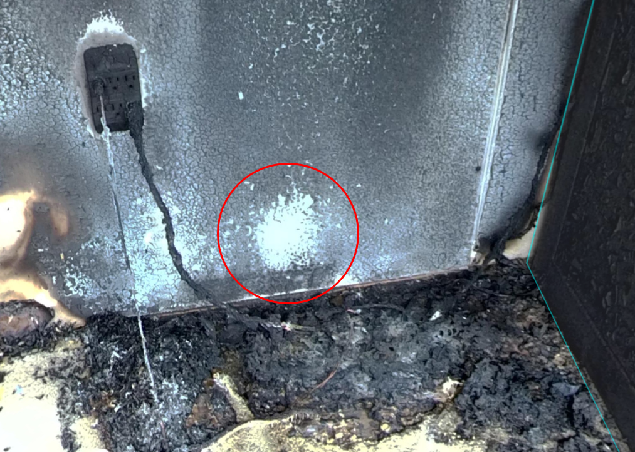

This burn pattern directly relates to the burn pattern on the outside of the Charlie wall that was identified in the initial 360-degree walk around, see photograph #3 which is copied below.

Photograph #3.

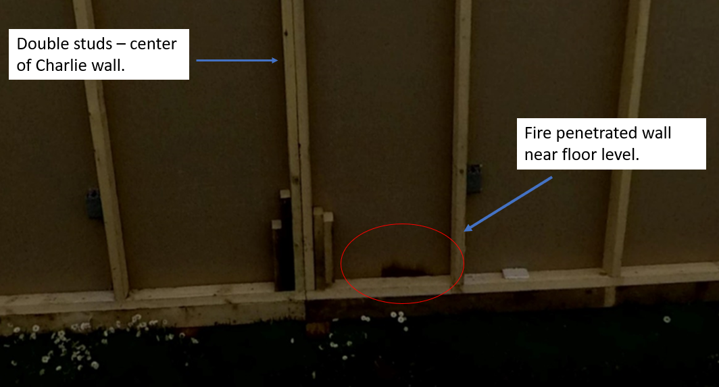

4.3 Heat of Ignition

The heat of ignition was an electrical failure in a power bar.

There were several electrical cords plugged into an electrical wall outlet in the Area of Origin as seen in photograph # 13 below.

Photograph #13

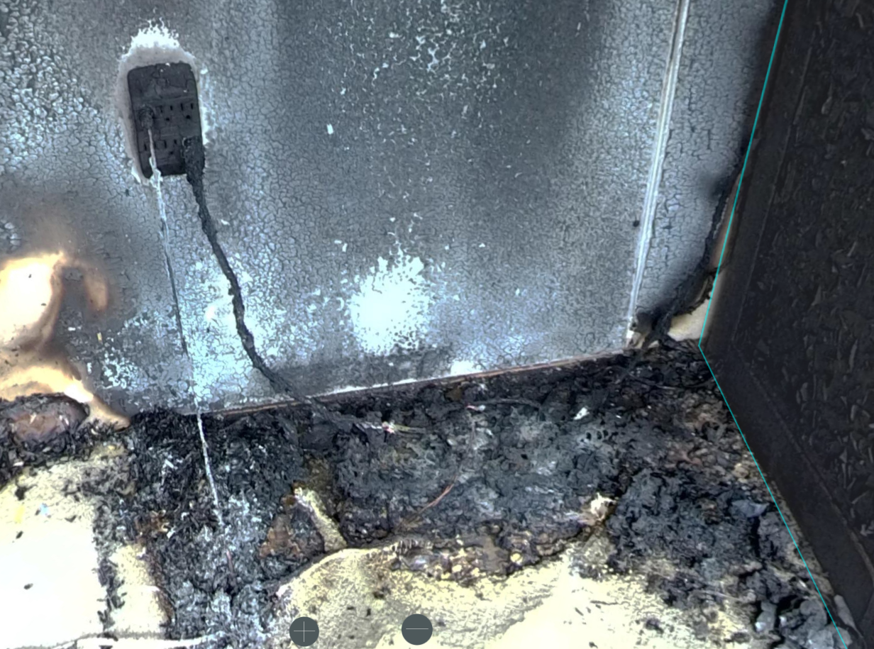

Due to the potential failure of the electrical components, Electrical Inspector Tom Edison of the Electrical Safety Agency was asked to inspect the electrical components.

Inspector Edison concluded that the wall circuit was intact. The cord on the left ran to the monitor on the desk on the Bravo side of the office. The insulation on the electrical cord to the computer monitor was burned off from the plug back about four feet but there was no indication of a short in the wire, so he concluded that the damage was a result of the fire not the cause.

Inspector Edison examined the remains of the electrical power bar that was found in the debris next to the filing cabinet. He told me that the power bar was almost totally consumed by the fire. He concluded that the power bar failed and likely caused the fire.

Mr. Edison said:

- they have lots of problems with power bars, especially cheap knockoffs.
- that up to 30% of small electrical products like the power bar are cheap knockoffs that show an approval agency label that is counterfeit.
- I should ask the owner where and when they bought the power bar and how much they paid for it. If it was cheap, there is a good chance that it is a knock-off product and if it is labelled by an approved testing agency the label is probably counterfeit.
- I should get the same power bar from the store, if they have one, and if they are counterfeit as he suspects have them discontinue sales.

My complete interview notes with Electrical Inspector Edison can be found in Appendix “C”. Should be Appendix “B”

I contacted the occupant (witness #1) and was told that he purchased some new computers and needed more electrical outlets, so he bought 2 power bars last week. He placed one of the power bars between the two desks on the back wall.

I arranged to interview with the occupant later that day at the fire scene. My complete interview notes with witness #1 can be found in Appendix “A”.

4.4 Material First Ignited

The material that first ignited was the plastic body of the electrical power bar, see photograph #14 below.

Photograph # 14.

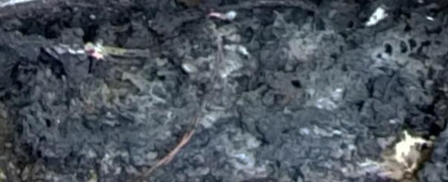

This photograph is a close-up of the area on the Bravo side of the two-drawer filing cabinet. This is the area of heaviest fire damage and material mass loss to the power bar due to consumption by fire.

If the damage to the power was from exposure to external fire, total consumption of the plastic shell would not have occurred, and it would be easily identified in the fire debris. This supports a fire starting in the power bar and extending outward and is consistent with previous test fires conducted by this fire investigator. The word “bar” is missing above

SECTION 5 CONCLUSIONS

5.1 Act or Omission

The cause of the fire was accidental and resulted from an electrical failure in the power bar.

This finding is based on the following information:

- Burn patterns confirm that the fire started at floor level close to the Charlie wall on the Bravo side of the two-drawer filing cabinet, see photograph # 15.

Photograph #15.

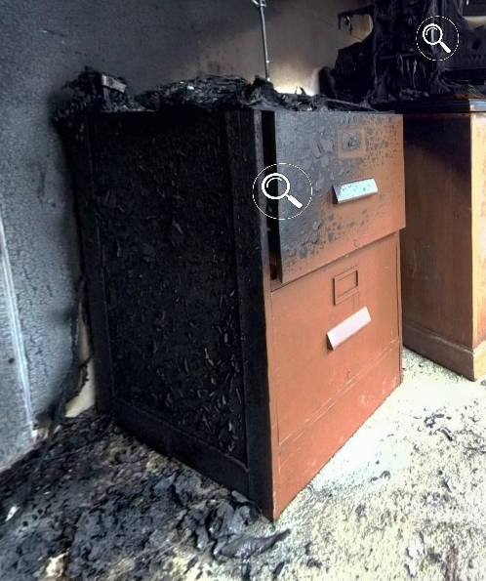

- The only mechanical or electrical equipment at this location was the electric power bar.

- The power bar was totally consumed by the fire which is consistent with the power bar being the material first ignited.

- No one was in the building at the time of the fire and there was no indication of forced entry prior to the arrival of the fire department.

- The power bar was recently purchased so an exemplar power bar was purchased from the same Dollar Store for $8.67, see photograph #16 below.

Photograph #16

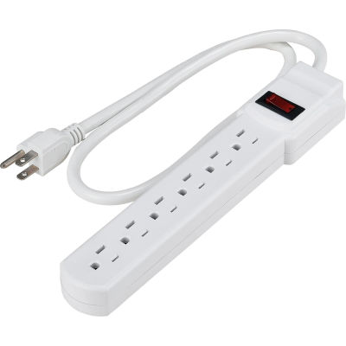

- On close examination by Electrical Inspector Edison, it was determined that the power bar had a fraudulent approval agency label on it. Without doing laboratory tests it was not possible to determine if the new power bar would fail.

Through discussions with the insurance adjusters, one for the building owner and one for the occupant, it was determined that there was no financial motive on behalf of the building owner or occupant to cause this fire. Notes from the interviews with the insurance adjusters can be found in Appendix “B” of this report.

Signature of Fire Investigator
Samuel Brown
The report does not indicate what action was taken to prevent the sale of other identical power bars. The Electrical Safety Authority should be involved to ensure identical products are prohibited from being sold.

APPENDIX (A) WITNESS INFORMATION and Interviews

Notes from interview conducted at the fire scene on November 6, 2022, at 16.15 hours.
Original notes on file.
Notes transcribed on December 6, 2022, by Administrative Assistant Mardell Corbett.

Witness #1
John Long,
Owner of Green Valley Accounting
6509 Front Street, Green Valley
Office number is 259-654-2203
Direct line is 259-654-2207
Cell number is 404-818-9866

Mr. Long told me the following

- Mr. Long is the owner of Green Valley Accounting
- He has rented the building for about 4 and a half years.
- He has not had any problems with the building up to this point.
- The landlords have been good to deal with and any time he has had a problem they fix it really quickly.
- One problem is they never seem to have enough electrical outlets. He purchased two new computers a few weeks ago and needed more electrical outlets, so he bought two power bars and a multi-plug outlet from the Dollar Store last week. The power bars cost under $10.00 each and the multi-plug outlet cost about $11.00. The total price was less than $30.00.
- He placed one of the power bars and the multi-plug outlet between the two desks on the back wall.
- He had been talking to Lorne and Fred Clark, the building owners, about repainting the office but really didn’t want to interrupt his business so he hoped they would do it over the holidays next Christmas. He said “Looks like we will get it painted now”.
- He has insurance through Brown Brothers Agencies that he thinks will cover the damage, but he doesn’t know about the building insurance.
- He has business interruption insurance but is concerned more about the possibility of losing clients. He doesn’t want to lose any of them.
- His business is thriving, and he just wanted to get the office open again as soon as possible as tax season is right around the corner.

The interview concluded at 16:25 hrs.

Witness #2
Notes from interview conducted with the building owner representative Lorne Clark at the fire scene on November 7, 2022, at 09.15 hours.

Fire Investigators Interview notes from interview
Original notes on file.
Notes transcribed on December 6, 2022, by Administrative Assistant Mardell Corbett.

Interview location outside 5678 Briar Lane, Green Valley
Date of Interview: November 7, 2022, at 09:15 hours.

The Interviewee is:
Mr. Lorne Clark, a partner in ACME Properties Ltd.
Address: 4478 Shoreline Drive, Green Valley
Office phone: 414-818- 2400 Direct line is 414-818- 2401
Cell phone: 404-818-2405

- Lorne Clark is a partner in ACME Properties with his brother Fred Clark.
- They have owned the building for 7 years and have been renting the building to Green Valley Accounting Services for the last 5 years.
- They have been great tenants so they hope they can recover from this quickly and keep Green Valley Accounting as a tenant.
- He said “They deal with John Long, who is the managing partner or maybe the owner of Green Valley Accounting. John Long seems to be the one that makes the decisions”.
- They have not had any problems with the tenant or the building in the past.
- Mr. Clark found out about the fire when the fire department called him about 09:45 on the morning of the fire.
- The building is insured, and he has already contacted the insurance company. They said they would get an adjuster over here as soon as they could.
- He asked if they could start cleaning up as we would like to get the building open again as soon as possible.
- The insurance company is Mutual Fidelity, and their office is on 6th Street, but he didn’t know their address.
- He said they have not had any previous insurance claims.
The interview concluded at 08:30 hrs. Interview times conflicting start time 09:15 finished at 08:30

APPENDIX (B) INTERVIEWS WITH PARTICIPATING AGENCIES.

Fire Investigators Interview with Electrical Inspector Tom Edison, Electrical Safety Agency

Notes from interview conducted at the fire scene on November 6, 2022, at 15.35 hours.
Original notes on file.
Notes transcribed on December 6, 2202, by Administrative Assistant Mardell Corbett.

Name: Tom Edison, Electrical inspector with the Electrical Safety Authority
Office address: 2121 – 21 Street, Green Valley
Office phone number: 365-765-7654
Cell phone number: 565-765-9654

- The wall circuits look intact, are properly wired, and did not, in his opinion, cause the fire.
- The cord running from the wall outlet to the computer monitor had the insulation burned off but was intact and was a result of the fire not a cause.
- He examined the remains of a power bar found in the debris.
- He mentioned they have had a lot of problems with power bars.
- Up to 30% of small electrical products are cheap knockoffs that show an approval agency label on them but in many cases the labels are counterfeit.
- I should ask the owner where and when they bought the power bar and how much they paid for it. If it was really cheap, there is a chance that it is a counterfeit knock-off product.
- The electrical authority has also had lots of problems with other cheap electrical products that are imported from China.
- It looked to him like the power bar was involved in the fire. It has suffered significant damage.
- The electrical safety agency does not pay for testing so he cannot send it off to a lab for testing.
- He said he could not say he was 100 percent sure that the power bar caused the fire, but he said that is what he thinks caused the fire. He said, “Judging by the total damage to the power bar, certainly was involved”.
- He recommended that I see if the store that sold it has any more that are exactly the same that we could look at it.
- If the power bars are counterfeit, as he suspects, they should not be sold.

The interview concluded at 15:55 hrs.

Fire Investigators Interview with Brown Brothers Agencies Insurance Adjuster

This interview is being conducted at the fire scene on November 7, 20222 at 09:45.
Original notes on file.
Notes transcribed on December 5, 2202, by Administrative Assistant Mardell Corbett.

Name: Amy Steel, Insurance adjuster, Brown Brothers Agencies,
Office address: #303 – 2234 Stone Hill Place, Green Valley
Office phone: 365-765-1191
Cell phone: 565-764-1192

- She is on for the building tenant Green Valley Accounting.
- Green Valley Accounting rents space from ACME Properties so they are not the building owner.
- They have content insurance and liability insurance but are not insured for the building.
- The insurance company is Southern Union Insurance and Brown Brothers Agencies is the insurance broker that sold the policy.
- Green Valley has been insured by Southern Union since they started business about five years ago and have not had any claims.
- Their policy is in good standing.

Questions and comments, Ms. Steel addressed the fire investigator.
- Can you tell me the cause of the fire?
- Can I go in and look around?
- Will you be filing a report?
- When do you expect to have your report completed?
- When do you think you will be releasing the scene?
- Who will you be releasing it to?
- Would you please notify us when that happens?
- If you will be taking any evidence away from the scene, would you please notify me or our private investigator?
- We will be assigning a private investigator due to the unlikely potential for subrogation.

This interview concluded on November 7, 2022, at 10:05 hours.

Fire Investigators Interview with Mutual Fidelity Insurance Adjuster Garth Keyler

This interview is being conducted at the fire scene on November 6, at 17:05 hours
Original notes on file.
Notes transcribed on December 5, 2202, by Administrative Assistant Mardell Corbett.

Name: Garth Keyler, Insurance Adjuster with Mutual Fidelity
His office address is #201 – 234 – 6th Street, Green Valley
His office phone number is 565-765-2411
His cell phone number is 564-705-8900

- Mr. Kyler is an insurance adjuster for Mutual Fidelity
- Mutual Fidelity has insured the property for Acme Properties for the last seven years.
- They have replacement cost insurance and business interruption coverage.
- The policy is up to date and was renewed about six months ago.
- They had one claim for water damage but that was to a different building they own.
- Acme Properties is a good customer.
- He is on for the building owner and has talked to the insurance adjuster for the tenant.
- He will meet Insurance Adjuster Amy Steel from Brown Brothers at the scene tomorrow but they have agreed that Mutual Fidelity will secure the property if it is released by the fire investigator today.
Questions from Mr. Keyler to the fire investigator.
- Can you tell me what your investigation has found so far?
Answer – Too early to tell for sure, but it looks like it involved some office equipment.
- Can I get in to do a quick assessment of the damage?
Answer – Yes, I will walk you through it, but you need some PPE including boots, gloves, hart hat, and respiratory protection.
- When do you think you will release the scene?
Answer – I just need a couple more hours and then I will probably release it.
- Will you be keeping security on it, or should I arrange for our security to take over?
Answer – It would be great if you would arrange for security but until I release the scene, they will they have to take their direction from me.
- Because there is more than one insurer, we will be assigning a fire investigator to the file, and I would like to arrange a time for the investigator to arrive. When do you think that could happen?
Answer – I expect to release the scene to you shortly, so they can have it any time after that.
- We would really like to get the repairs done as soon as we can, so we really need to assess the damage.
Answer -Get your PPE on and we will have a look.
This interview concluded at 17:21 hours on November 6, 2022.

Fire Investigators Interview with Incident Commander Albert Shaw
This interview is being conducted at the scene on November 6, 2022, at 10:55 hours.
Original notes on file.
Notes transcribed on December 5, 2202, by Administrative Assistant Mardell Corbett.

Name Albert Shaw, Captain, Green Valley Fire Department,
Address is 2342 Park Lane, Green Valley
Cell Phone: 259-656-7789

- Captain Shaw was the Incident Commander for this fire.
- He has worked for the Green Valley Fire Department for 16 years.
- He got the call just as his crew were coming on shift today just after 08:00 hours.
- They responded with Command 1 and Engine 4
- Shaw established command at 08:12 hours.
- He did a 360 around the building and found that it was a single story, wood frame building, and the fire appeared to be contained to the office.
- The main entrance door was secure, so they forced entry.
- They entered with one– 38mm attack line.
- The first-in firefighters were Wanda Johnson and William Wakely. They quickly knocked down the fire with a minimum of fire damage.
- After overhaul, he called for an investigator because of distinct burn patterns he thought may be electrical in nature, and he did not want to disturb anything before the fire investigator had a look at it.
- He said he asked dispatch to notify the building owner and the occupant, and the occupant is here and the building owner is on the way here.
- There are no abnormal safety hazards to be concerned with.
- Regular PPE should be all that is required.

This interview concluded at 10:55 on November 6, 2022. Interview time starts and finish are the same.

No interviews with the first in firefighters.

APPENDIX (C) PHOTOGRAPH LOG

Photograph log incomplete.

Photo #1
This photo shows

Photo #2
This photo shows

Photo #3
This photo shows

Photo #4
This photo shows

APPENDIX (D) SKETCHES AND DRAWINGS

Drawing RS-1 Floor Plan, Green Valley Accounting, 5678 Briar Lane, Green Valley.
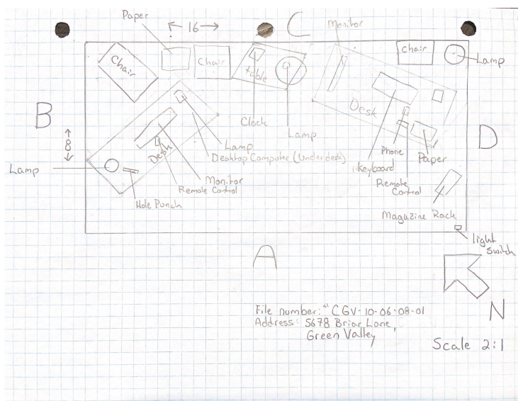

Drawing RS-2 `Site Plan of Green Valley Accounting Services 5678 Briar Lane, Green Valley.
Site Plan missing

Deficiencies in the Fire Report
The deficiencies in the report are listed below with a grade mark for each. There is room at the bottom of the table to add deficiencies and comments from the students.
Page # | Points | Report Mistakes or Omissions
1 | 1 | Incident number on first page not consistent with the incident # in the footer.
2 | 2 | Table of Contents requires updating
2 | 2 | Table of Content missing 4.3 Heat of Ignition
2 | 1 | Witness information starts on page 16 not 18 as in the Table of Contents
3 | 2 | Act or Omission on page 3 not consistent with findings in Section 5.1 of this report. 5.1 says accidental - Executive summary says undetermined
4 | 2 | Page 4 Building Sketches  A rough sketch of the site plan is attached as drawing RS1 in Appendix “D” No site plan provided in the Appendix
4 | 1 | A rough sketch of the floor plan and contents can be scene in drawing RS2 in Appendix “DC”.  “Scene” should be “seen”. Appendix “DC” should be Appendix “D”
5 | 1 | Page 5 The only fire indicator on the Bravo side was slight melting of plastic near the Bravo–Alpha corner. Could have inserted a photo of Bravo side.
6 | 1 | No mention of examining the outside of the Delta wall. Page 6 before the Interior Examination took place.
13 | 1 | My complete interview notes with Electrical Inspector Edison can be found in Appendix “C”. Should be Appendix “B”
13 | 1 | If the damage to the power was from exposure. The word “bar” is missing after power in the first sentence above Section Five Conclusions.
15 | 5 | The report does not indicate what action was taken to prevent the sale of other identical power bars. The Electrical Safety Authority should be involved to ensure identical products are prohibited from being sold.
17 | 1 | The interview with Witness #2 concluded at 08:30 hrs. Interview times conflict- start time 09:15 finished at 08:30
21 | 1 | Page 21 Interview with IC Shaw starts at 10:55 and ends at 10:55
21 | 3 | No interviews with fire in firefighters were recorded.
22 | 3 | The Photo log is incomplete.
24 | 2 | Site Plan is missing.
 |  | Total Points
 | 30 | Maximum Total Points Available
 |  | Add new items identified by the students here.

