FIRE INVESTIGATION SCENARIO #1
KITCHEN FIRE

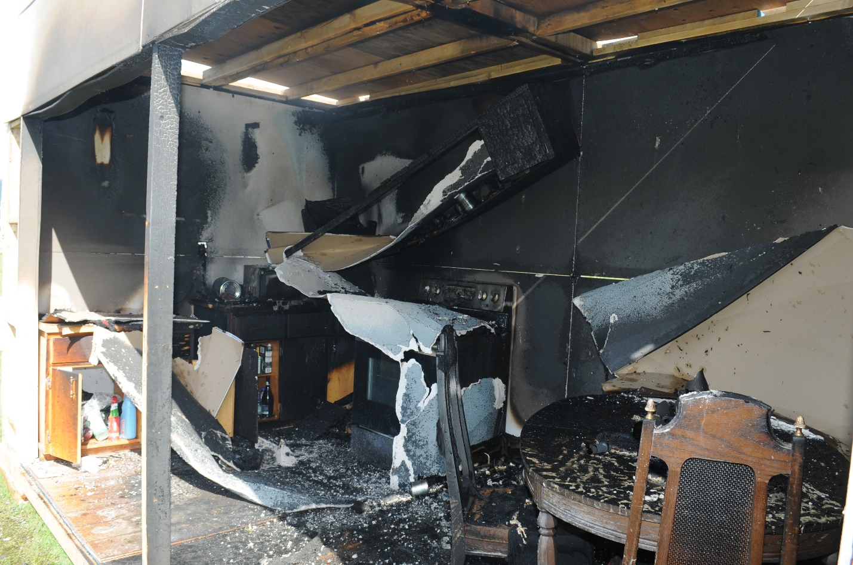

Fire Investigators Background Information

There was a kitchen fire in a home at 2785 Main Street, Campbell Hill. The fire department got the call on today’s date at 0030 hours from a member of the Campbell Hill Police Department, Constable John Night. Campbell Hill Fire Department responded, and the Incident Commander (IC) was Captain Dennis Wett.

The fire scene has been secured since the time of the fire.

You are the fire investigator for Campbell Hill Fire Department, and you have been asked to conduct a fire origin and cause investigation.

You arrive on the scene at the current time and date.

Assignment

Complete the fire investigation and write a report on your findings. Your report can be a completed or modified Fire Investigation Field Form or a technical report using your preferred format. Copies of the Fire Investigation Field Form are available in the Materials Section of this Practical Exercise. A sample copy of a technical report can also be found in the Materials Section. Submit your completed report to the evaluator assigned to your course.

In addition to completing the fire investigation report, you are required to prepare and present a PowerPoint presentation online to your evaluator that you must submit as part of your assignment. Your presentation should record in detail the activities you undertook to conduct this investigation but should not exceed 15 minutes in length. A sample presentation is provided in the Materials Section.

Fire Investigators Interview with Constable John Night
PO Box 287
Campbell Hill
Phone: 444-467-7777

Interview conducted at the current time and date.

Interview starts with you thanking Constable Knight for returning to the scene for the interview.

Interview

My name is Constable John Knight, and I am a member of the Campbell Hill Police Department.

My address is 398 22nd. Street, Campbell Hill

My phone number is 444-467-7777

My badge is #867

I joined the police department 10 years ago and am assigned to general duties.

At about 00.28 hours I was driving by 2785 Main Street, Campbell Hill when I saw the fire.

It appeared to be in the kitchen portion of the house.

I radioed dispatch and reported the fire and then I walked around the property waiting for the fire department to arrive.

There was no one else around but after the fire department arrived the neighbor, Mr. Charles Smart, showed up and talked to me.

I asked Mr. Smart to stick around as I wanted to interview him later.

Fire investigator interview with Incident Commander, Captain Dennis Wett.
Interview conducted at the current time and date.
Interview starts with you thanking Captain Wett for returning to the scene for the interview.

Interview

My name is Dennis Wett and I am a Captain with Campbell Hill Fire Department and I was the Incident Commander for this fire.

My address is 2342 Hillside Ave, Campbell Hill

My phone number is 778-919-9123

We were dispatched at about 00:30 hours to a structure fire at 2785 Main Street. We responded with Engine 7, Rescue 1, and Battalion 1.
We arrived on scene at approximately 00:37 hours and there were flames coming from the area of the kitchen and the fire was in the fully developed stage.
After size-up I assigned an attack line to enter the kitchen area on the Alpha side of the structure. Firefighters Johansen and Miller were the first in attack crew.
They were able to knock down and extinguish the fire easily with the one attack line.
We then commenced overhaul to insure complete extinguishment.
When we arrived there was a police officer on scene but nobody else was around. Some other people showed up during suppression but nobody I talked to knew anything about the fire.
I talked to the police officer, Constable John Knight. He said he was driving down Main Street and saw the fire in the house. When he approached the building, he saw that the fire was in the kitchen area.

Knight also said that he was going to interview a neighbor, Mr. Charles Smart, who was at the house earlier in the evening.

As we were wrapping up, I called for security to guard the building until you arrived. We wrapped up and returned to the hall at approximately 02:55.
I called for an investigator because of the extent of the damage and the fact that we could not locate the property owner. Apparently, he has left town.
Fire Investigators Interview with Security Guard Ann Bell
Interview conducted at the scene at the current time and date.

Interview

My name is Ann Bell and I am a security guard with Campbell Hill Security.

My address is 2464 Pleasant Street, Campbell Hill

My phone number is 778-818-9801

I received a call from my boss around 01:45 this morning asking me to attend a fire scene at 2785 Main Street, Campbell Hill.

I arrived at the scene at 02:25 and met with the fire guys. They asked me to secure the scene and to not let anyone in without calling and getting permission from the duty officer at the fire hall first.

The fire department had taped the area off and nobody entered beyond their tape.

I was told to stay here until the fire investigator arrived and dismissed me.

There were a few people at the scene, but they all left when the fire department did which was at 02:51.

There has been some people driving by to have a look but nothing unusual and nobody has approached me or entered the taped off area.

Fire Investigator Interview with first in firefighter Bob Johansen.
Interview starts with you thanking firefighter Bob Johansen for returning to the scene for the interview.

Interview conducted at the current time and date.

Interview
My name is Firefighter Bob Johansen
My address is 5871 Crest Ave, Campbell Hill
My phone number is 778-814-4884
I have been a firefighter with Campbell Hill Fire Department for 8 years.
We were dispatched at about 00:30 hours to a structure fire at 2785 Main Street. I responded in Engine 7.
When we arrived on scene, there were flames coming from the area of the kitchen and the fire was in the fully developed stage.
We donned our PPE and firefighter Reg Miller, and I were the first in crew.
The kitchen door was locked but we were able to easily gain access by breaking the window in the door and unlocking it.
We entered through the kitchen door with a hand line and were able to quickly extinguish the fire. The fire went out rapidly with minimal application of water.
We mopped up the fire and returned to the station at about 03:00 hours.

Fire Investigator Interview with Firefighter Reg Miller
Interview starts with you thanking firefighter Reg Miller for returning to the scene for the interview.

Interview conducted at the current time and date.

Interview
My name is Firefighter Reg Miller
My address is 1758 Peak Street, Campbell Hill
My phone number is 778-414-8448
I have been a firefighter with Campbell Hill Fire Department for 2 ½ years.
We were dispatched at about 00:30 hours to a structure fire at 2785 Main Street. I responded in Engine 7.
When we arrived, there were a lot of flames coming from the Alpha side of the building.
Firefighter Bob Johansen and I were the first in crew. Once we got our hose line charged and SCBA on we attached the fire through the kitchen door.
There were a lot of flames and heavy black smoke, but the smoke seemed to change from black to white as soon as we hit it with water.
We entered through the kitchen door with a hand line and were able to quickly extinguish the fire.
We cleaned up the scene and loaded our equipment and returned to the fire house around 3 o’clock.

Constable KKnights provide Fire Investigator with a copy of his interview
with neighbor Mr. Charles Smart
2765 Main Street
Campbell Hill
Phone: 444-467-8878

My Name is Charlie Smart and I live at 2765 Main Street, Campbell Hill

My phone number is 444-467-8878

I was at home when I heard the sirens, so I came outside to see what was going on.

Bill’s house was on fire and the fire department was just arriving.

It seemed to take quite a while for them to get the hoses off the truck and water flowing but they put the fire out quickly when they hit it with water.

The house is owned by Bill and Sharon Potts. Sharon is away right now, and Bill has just lost his job at the mill along with all the rest of the workers, so he is taking off to look for work. I am not sure where or when he is going.

We had a wake tonight over the loss of their jobs with a few of the guys that Bill worked with. We ran out of beer around 11 or maybe a little later so they decided to head to the bar. I was pretty loaded, so I decided to go home.

Oh, Bill and Sharon were good neighbors, but we were not really close friends. I know that they were having some problems and wanted to sell the house, but nobody is buying right now with the mill shutting down.

Sharon left about a month ago and I think she is staying with her parents.
They were good neighbors, we got along fine but they are going through a rough patch right now.

I was working on the fence between our properties when the guys arrived, and Bill invited me over.

The last time I saw Bill was when the guys headed to the bar, and I went home.

Fire Investigator Interview with neighbor Mr. Charles Smart

My Name is Charlie Smart and I live at 2765 Main Street, Campbell Hill which is next door to where the fire took place.

My phone number is 444-467-8878

I was at home and had just gone to bed when I heard the sirens.

I came over and the fire department was here along with a police officer. I talked to the police officer and told him what I know but I can tell you as well.

The house is owned by Bill Potts and his wife Sharon. They were good neighbors, but I would not say we were close friends, but we got along fine.

Bill and a whole lot of others lost their jobs due to the mill closing and things have not been all that great in his marriage. Sharon left town about a month ago to stay with her mother and I heard they are having a bitter dispute over selling the property.

They have had the place up for sale for quite a while but because of the mill closure the real estate market is depressed and nothing is selling.

Bill is leaving town very soon, if he has not already left, to try and find employment elsewhere. I don’t know where he is going, but I heard there is some work up north so perhaps that’s where he is headed.

Bill had a party or a wake at the home last evening with some of his coworkers that also lost their jobs. The party started around 5 pm after they got off shift.

I was repairing some fencing between our property and Bill’s when the group arrived, and Bill invited me over. We were all having a few beers and several of the people were smoking pot, including Bill and we were all getting pretty drunk.

Around 11:30 we ran out of booze, so they decided to continue the party at the local bar. The group headed to the bar, but Bill said he had some things to do before he left and would join them later. I had had a lot to drink so I decided to go home.

I left about 11:45. That is the last time I saw Bill and I don’t know where he is now.

Fire Investigator interview with the Electrical Inspector Shirley Goodgame

Interview
My name is Shirley Goodgame, and I am an electrical inspector with the Electrical Safety Authority.
I have worked for the authority for 7 years and am a red sealed electrician.
My address is 3344 Mountain Heights Road, Campbell Hill
My phone number is 778-812-8765

I can’t really see anything wrong with any of the electrical equipment in the house. I checked the wiring for the kitchen lights and plugs and the stove and they are all to code and show no signs of failure.
I looked at the microwave and what was between it and the end wall as you asked. I think the other item is the remains of a coffee pot. The damage is extensive to both but from my limited experience with small appliances it is hard to tell if either one caused the fire.
You should check with the owners to see if they have had any problems with them. The coffee pot seems to have a lot more damage than the microwave, but both are heavily damaged. You should ask the owners if they know where and when they were purchased?
To tell much more, they would have to be examined by a lab.
It is against our agency policy to send items away for lab analysis unless there are important extenuating circumstances but perhaps the insurance adjuster would send them to a private lab.
If you need anything further just give me a call.

Fire Investigator Interview with Insurance Adjuster Jack Murphy

Interview conducted at the current time and date.

Interview

My name is Jack Murphy

My address is 2234 – 36th Street Southeast, Campbell Hill

My phone number is 444-467-9312

I have been an adjuster for IGM Southern Union Insurance Company for 15 years.

The house is owned by William and Sharon Potts.
The policy number is IGM 040103-2017
It has been insured since 2017 for replacement cost.
There was one minor claim in 2019 for water damage from a leaking dish washer.
Their premiums are up to date and no changes have been made to their policy since it was last renewed 11 months ago.
It is due for renewal next month.

